**Oracle SQL Foundations 5-6**

Project Questions

**Name**: Kamran Butt

**Date**: September 17, 2024

**DFo_6_1_Project**

**Question**:

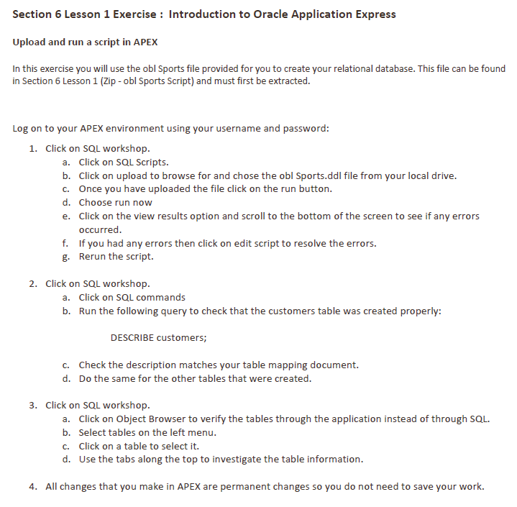

**Answer**:

1. 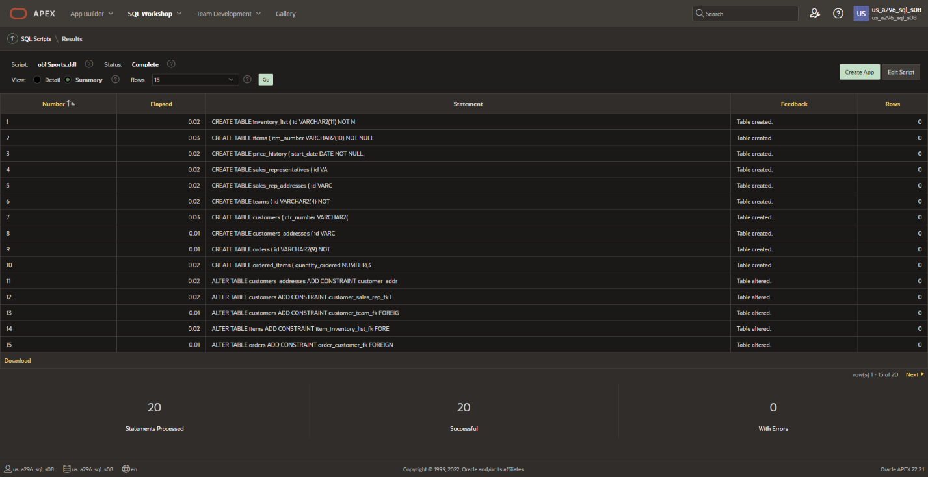
2. 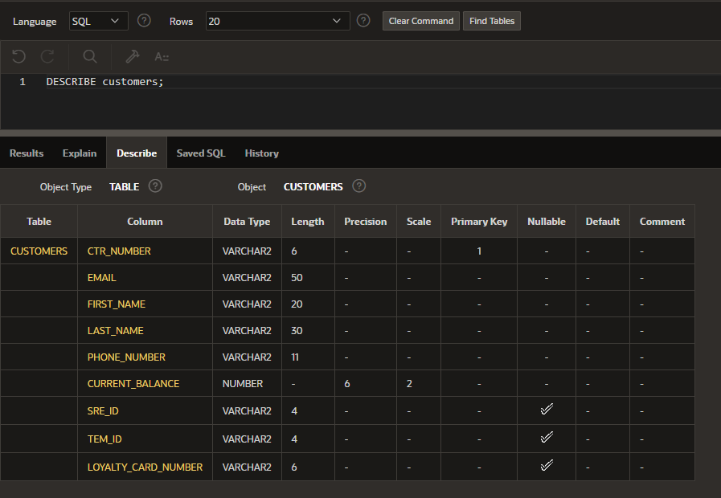

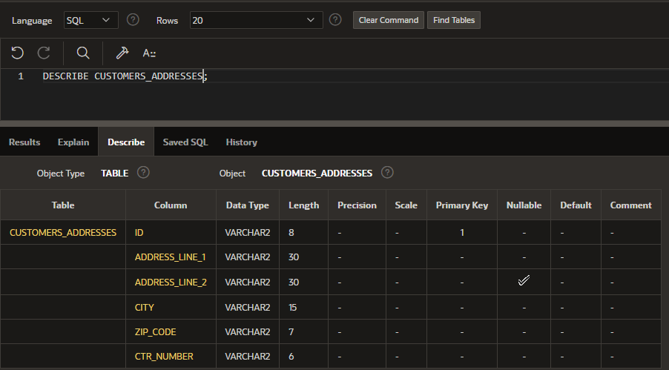

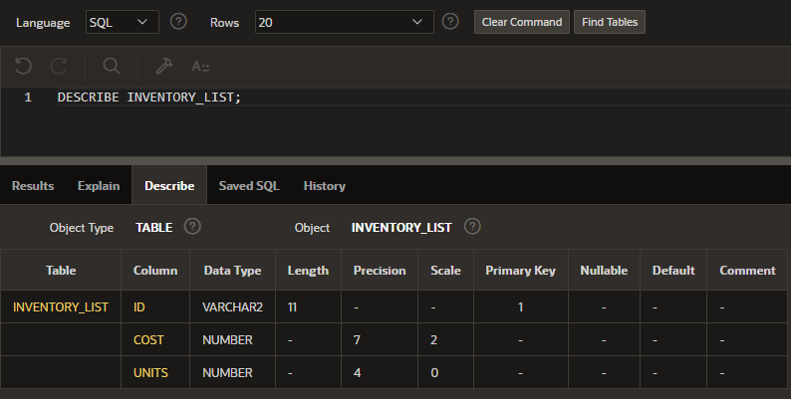

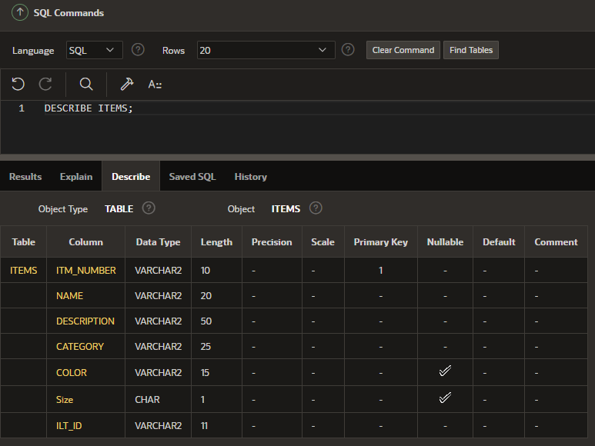

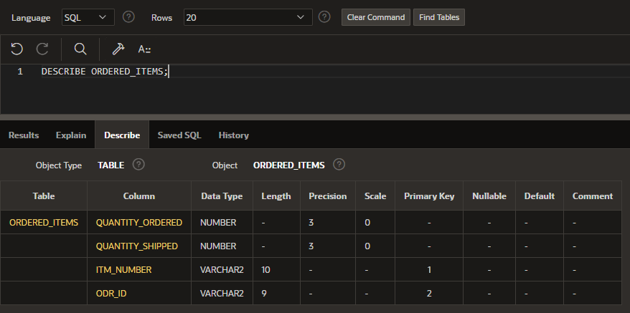

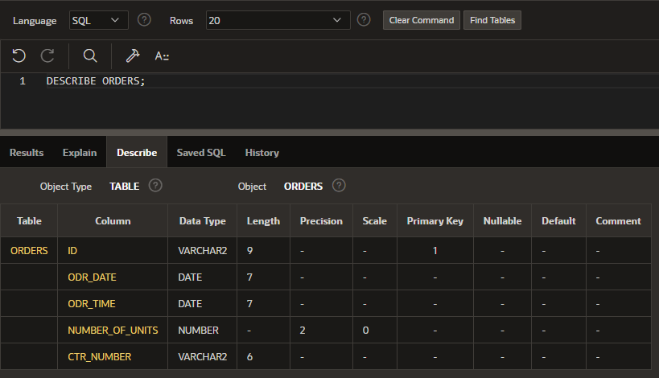

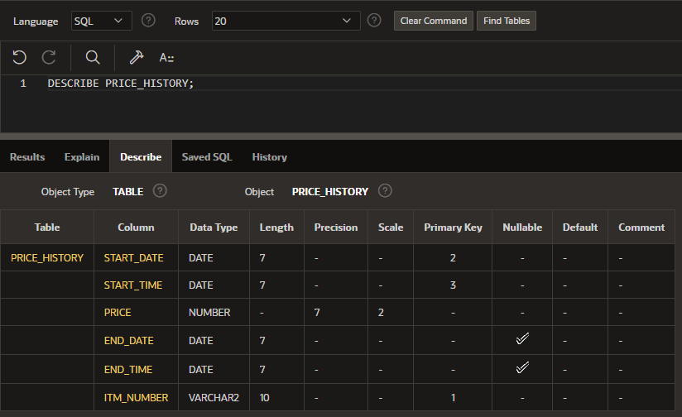

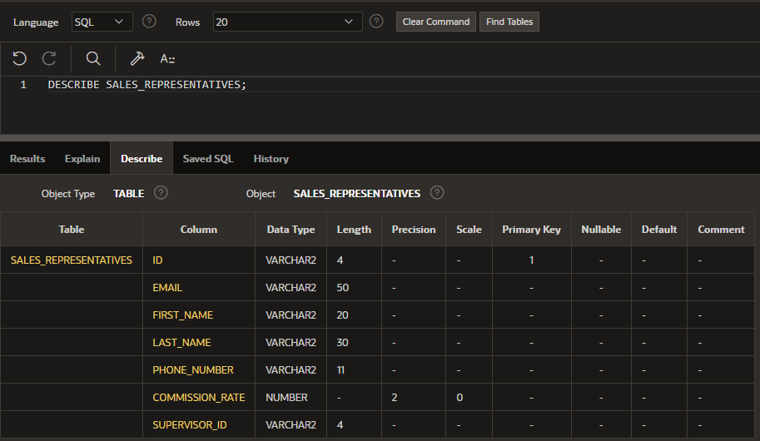

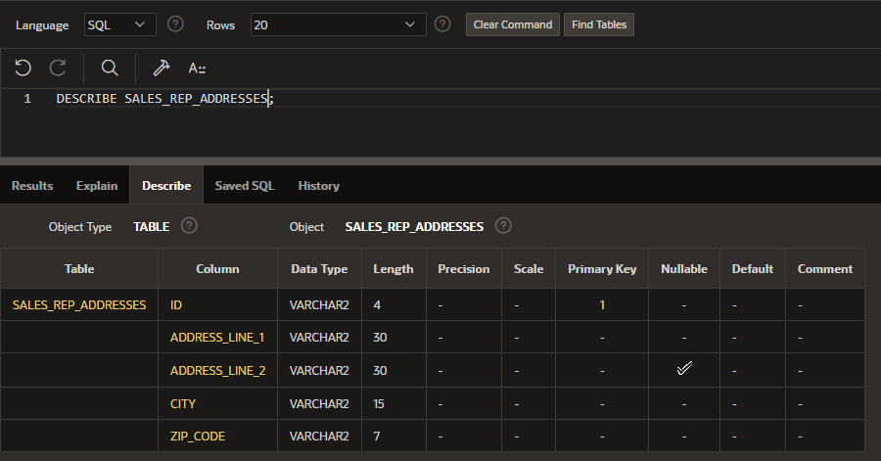

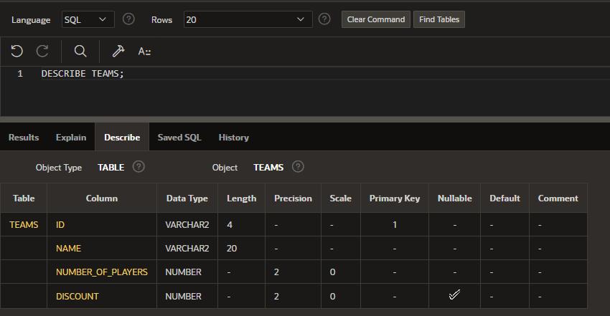

1. Object Browser

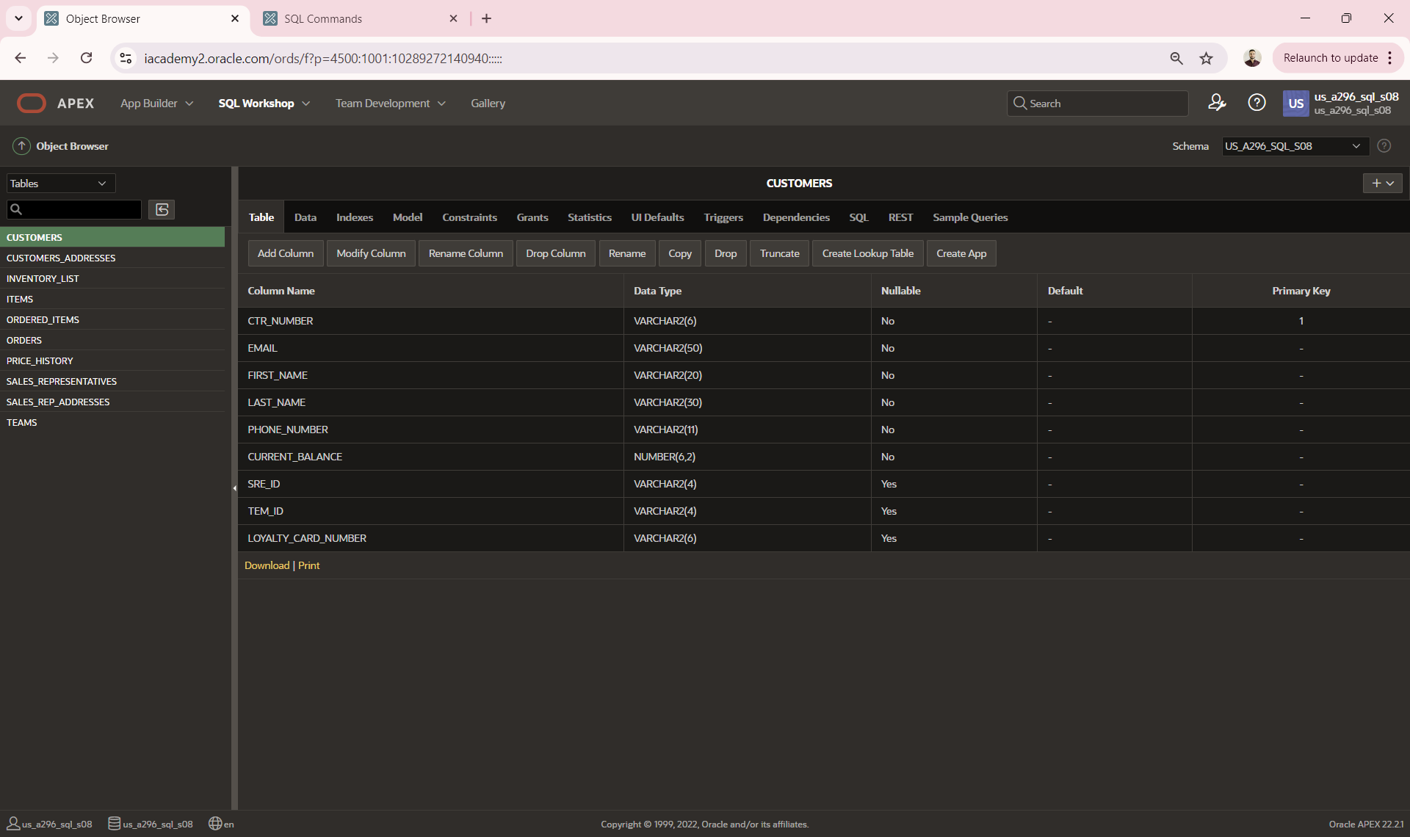

**DFo_6_3_Project**

**Question**:

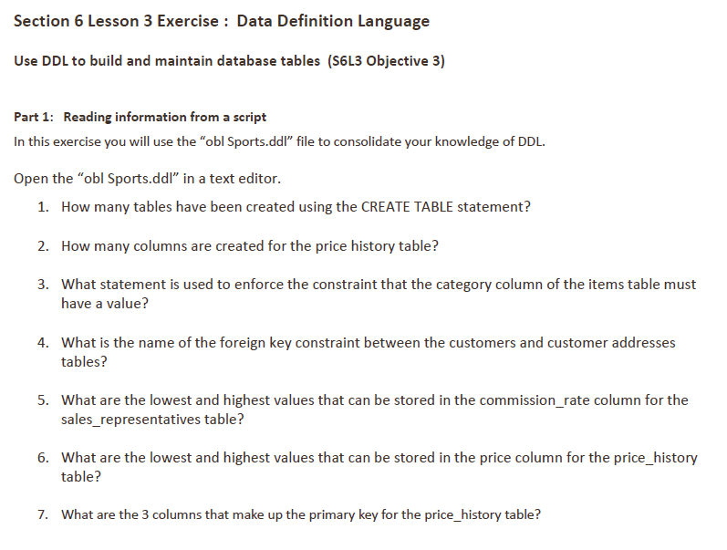

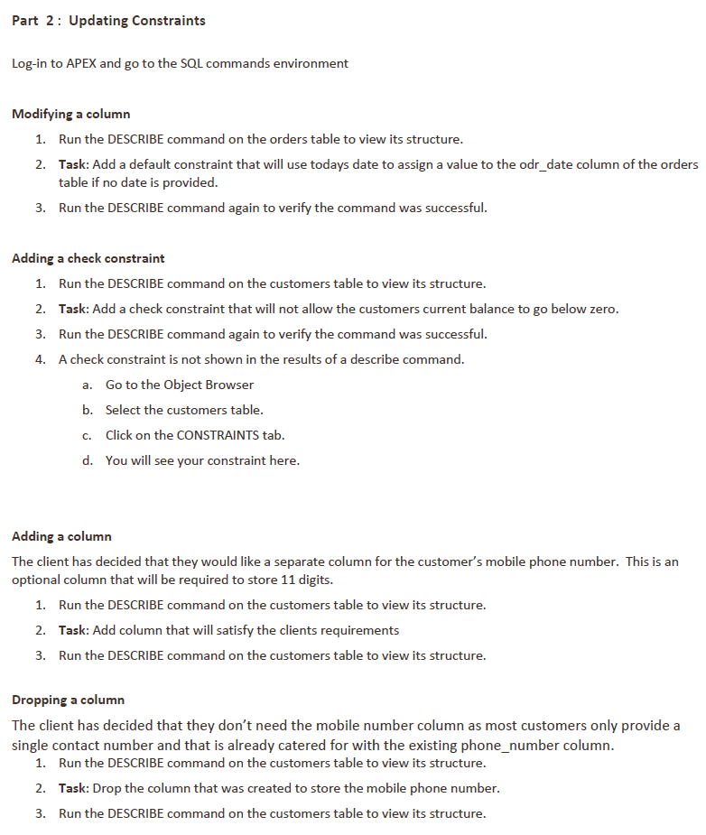

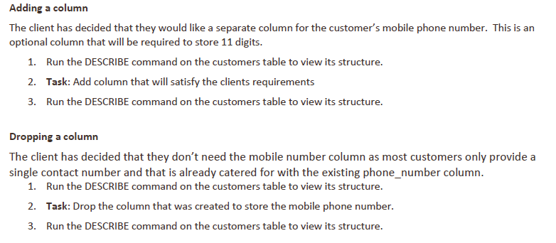

**Answer**:

*Part 1*

1. 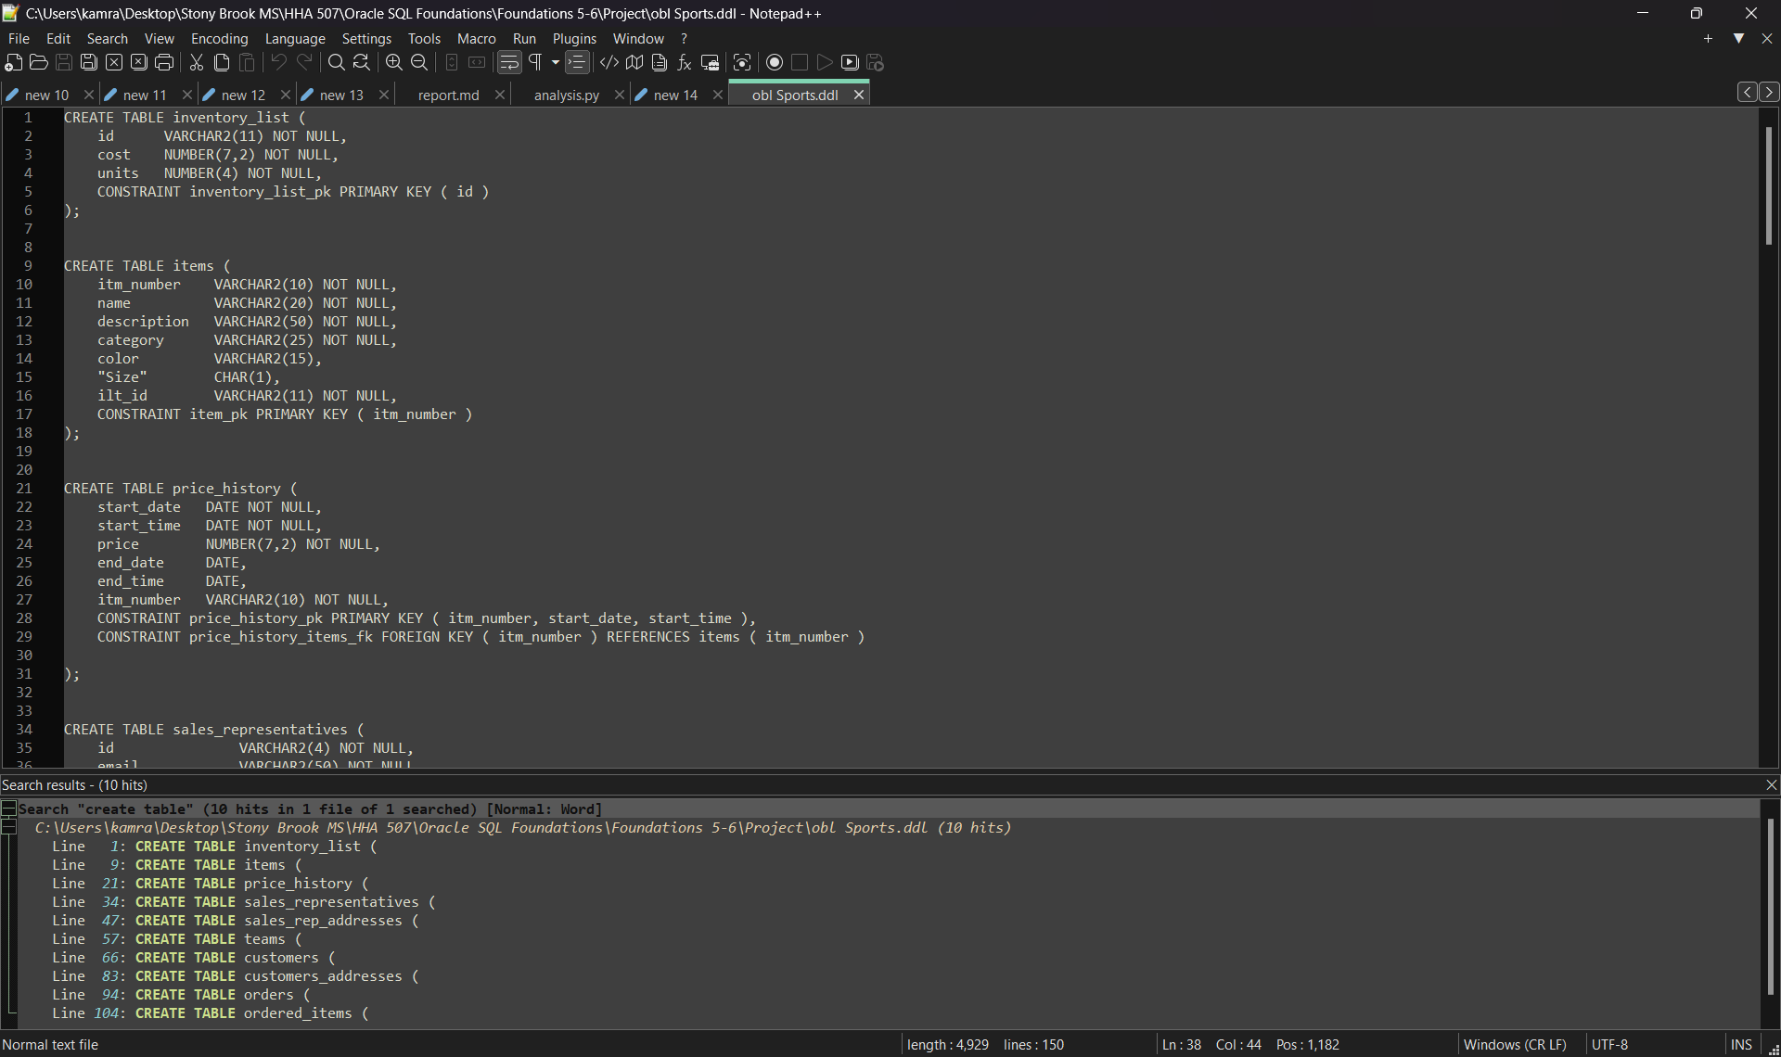10 tables are being created in the obl Sports.ddl file
2. There are 6 columns created in the PRICE_HISTORY table

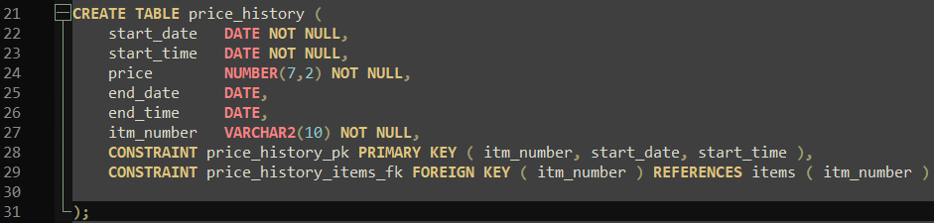

1. The statement that enforces the constraint that the CATEGORY column must have a value is:

VARCHAR2(25) NOT NULL

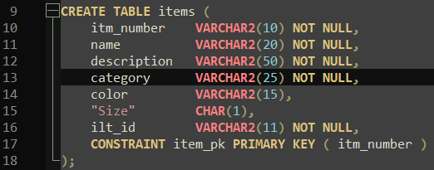

1. There is no foreign key constraint defined between the customers and customers_addresses tables in the provided file.
2. The commission_rate column is defined as NUMBER(2) NOT NULL, which suggests it can store values between 0 and 99.
3. The price column in the price_history table is defined as NUMBER(7,2), which suggests the values can range from 0 to 99999.99.
4. The primary key for the price_history table consists of the columns: itm_number, start_date, start_time.

*Part 2*

1. Modifying a column

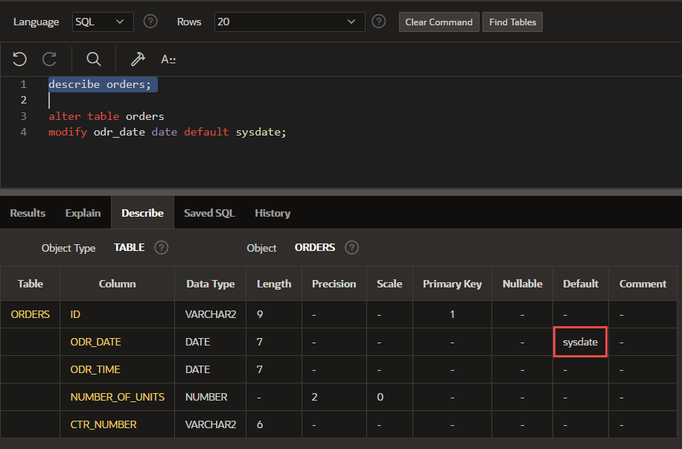

1. Adding a check constraint

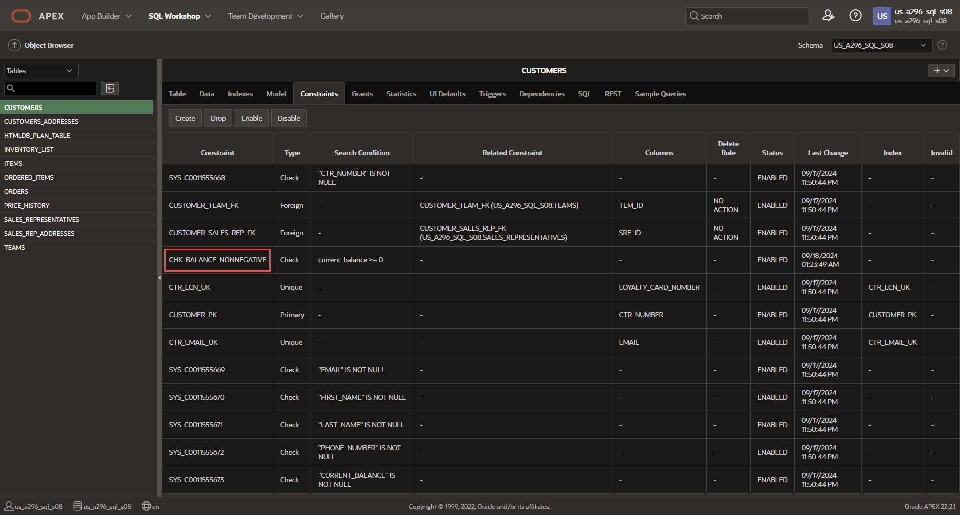

1. Adding a column

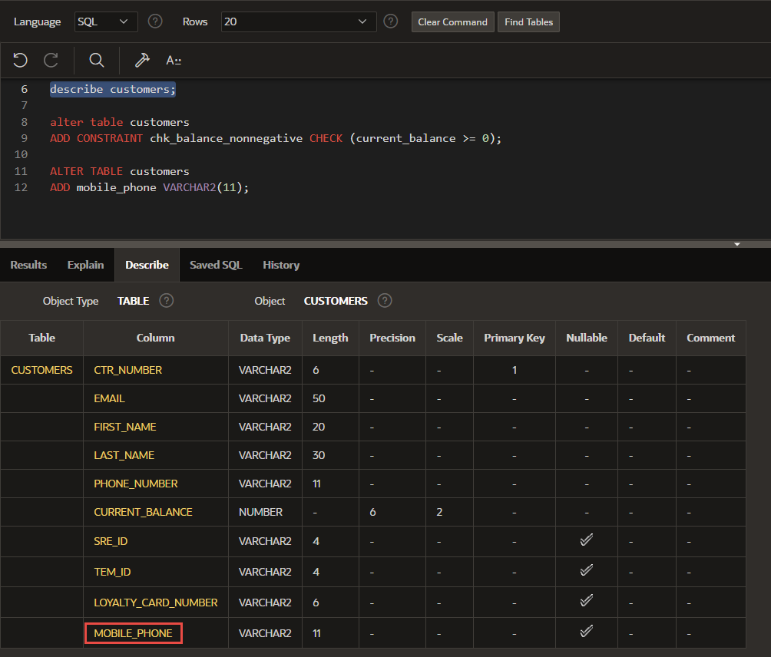

1. Dropping a column:

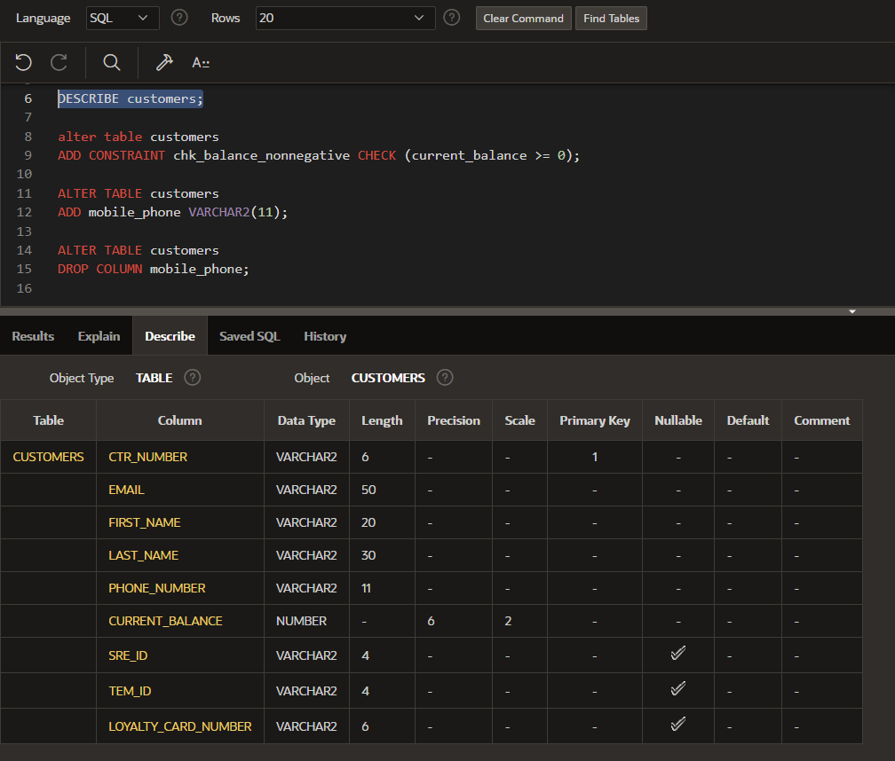

**DFo_6_4_1_Project**

**Question**:

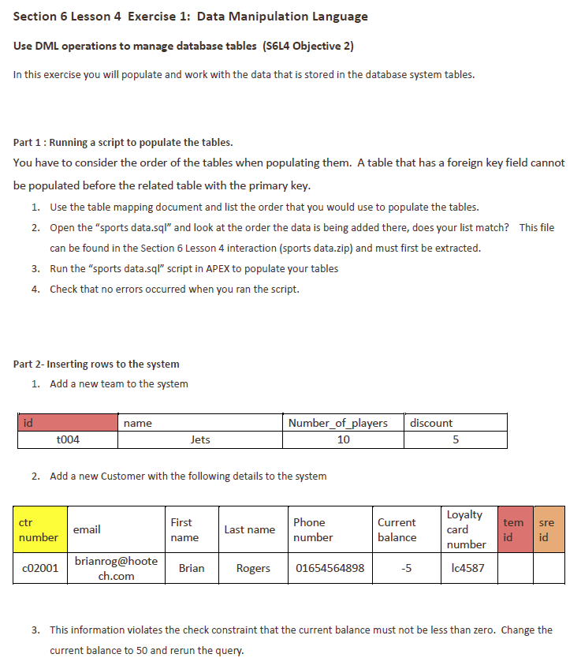

**Answer**:

*Part 1: Running a script to populate the tables*

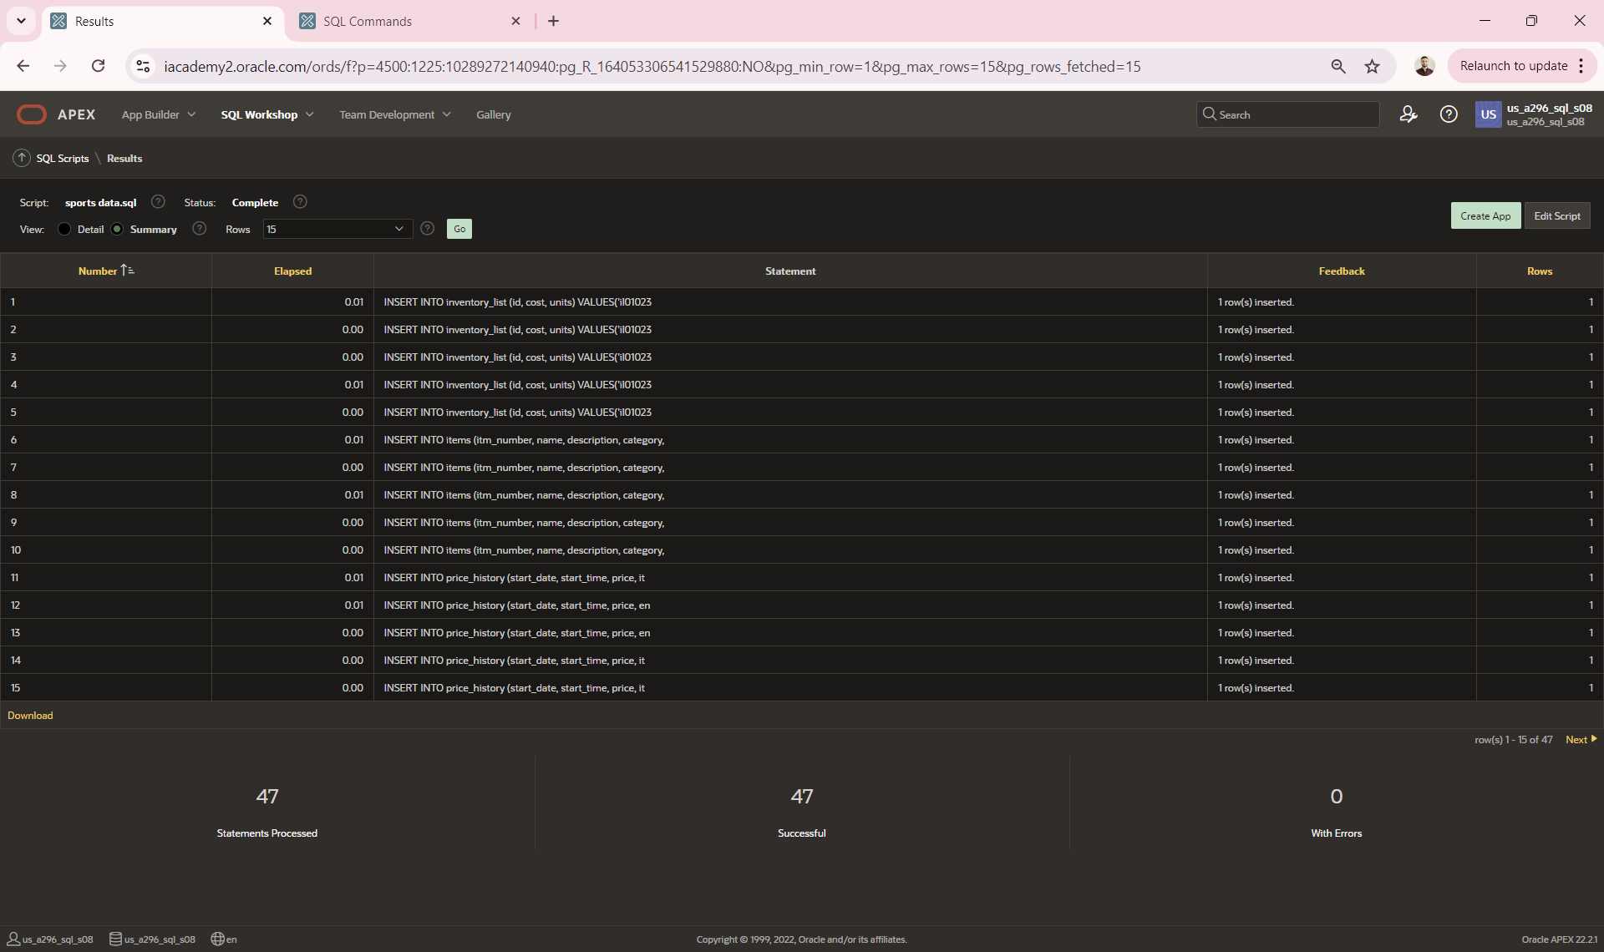

*Part 2: Inserting rows into the system*

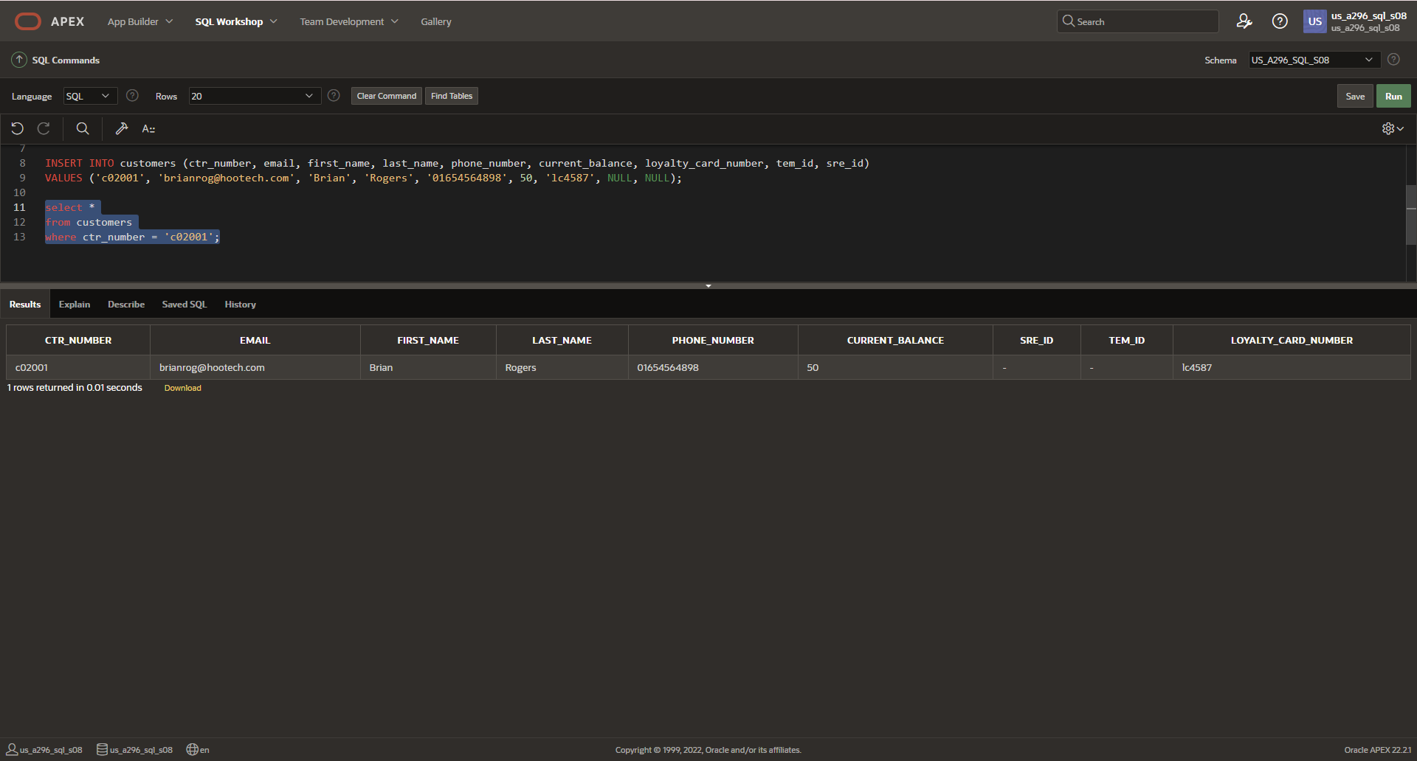

**DFo_6_4_2_Project**

**Questions**:

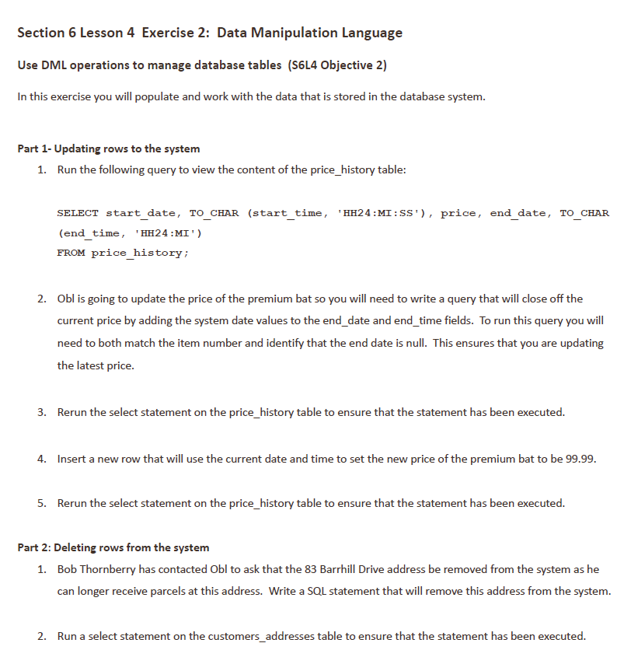

**Answers**:

*Part 1*:

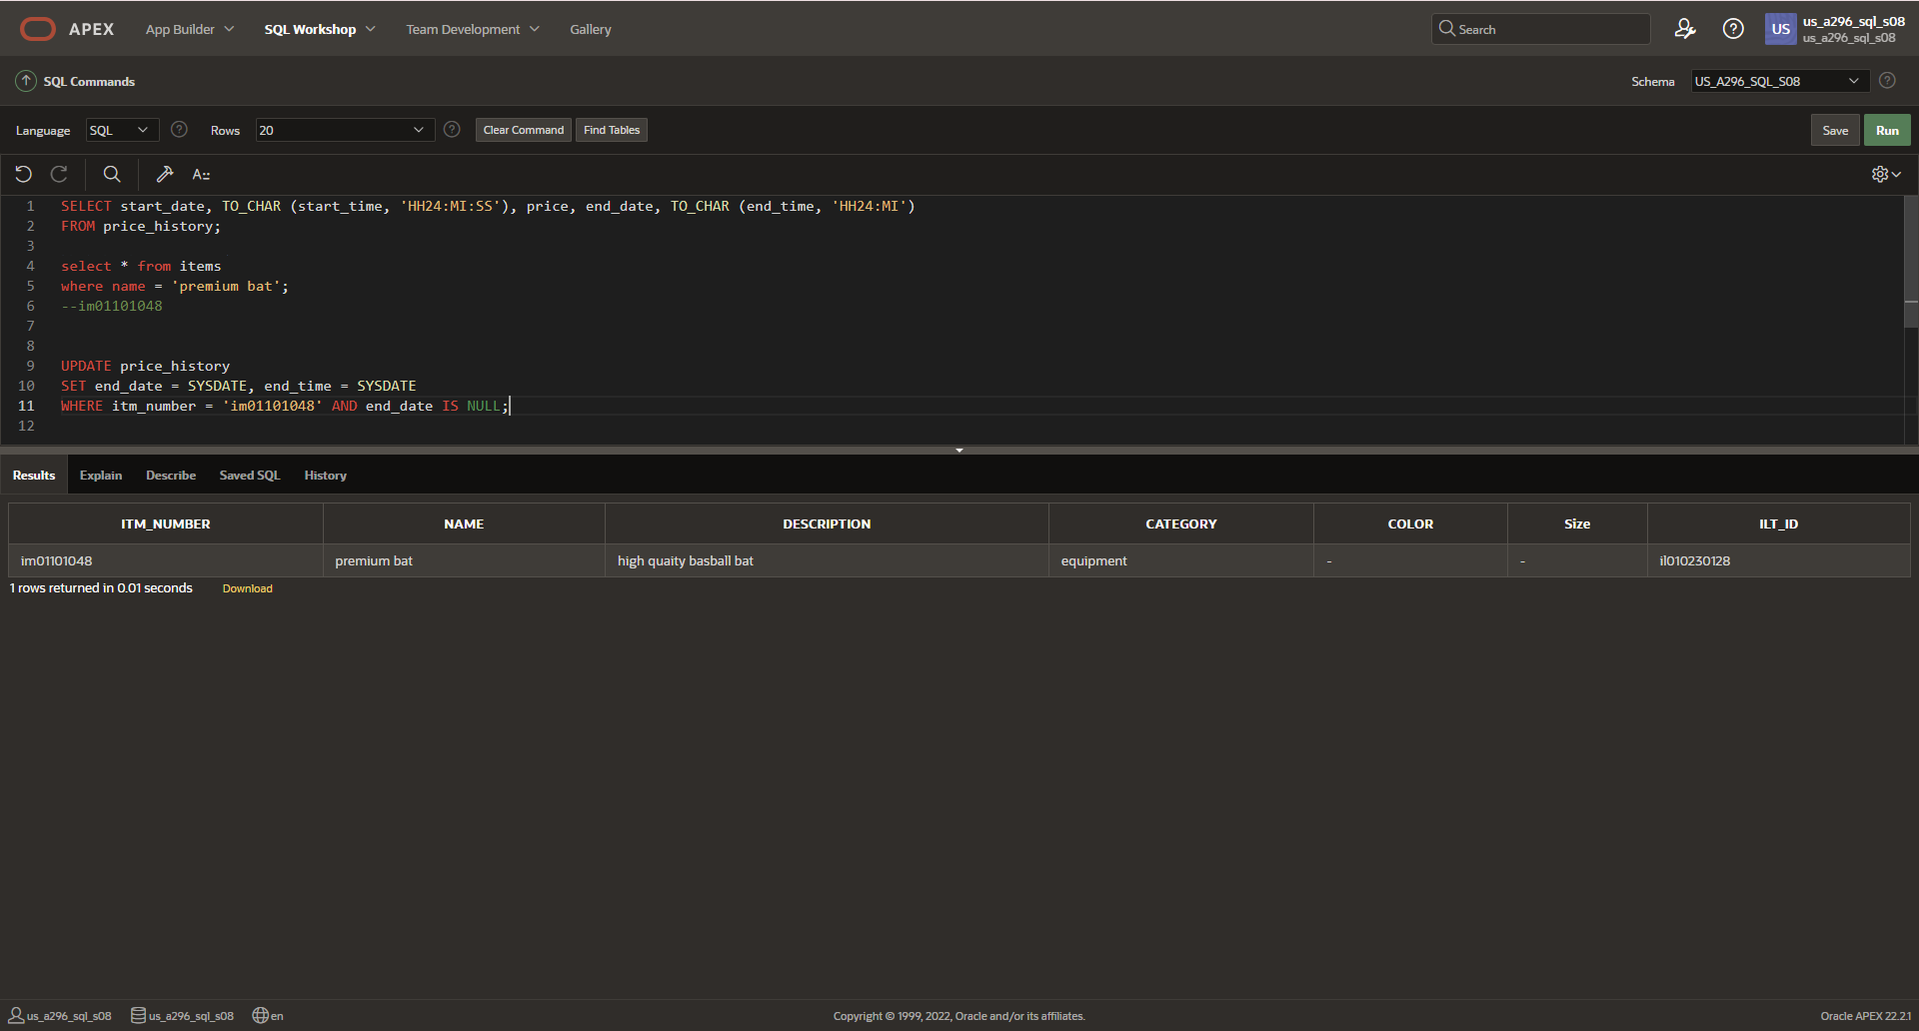

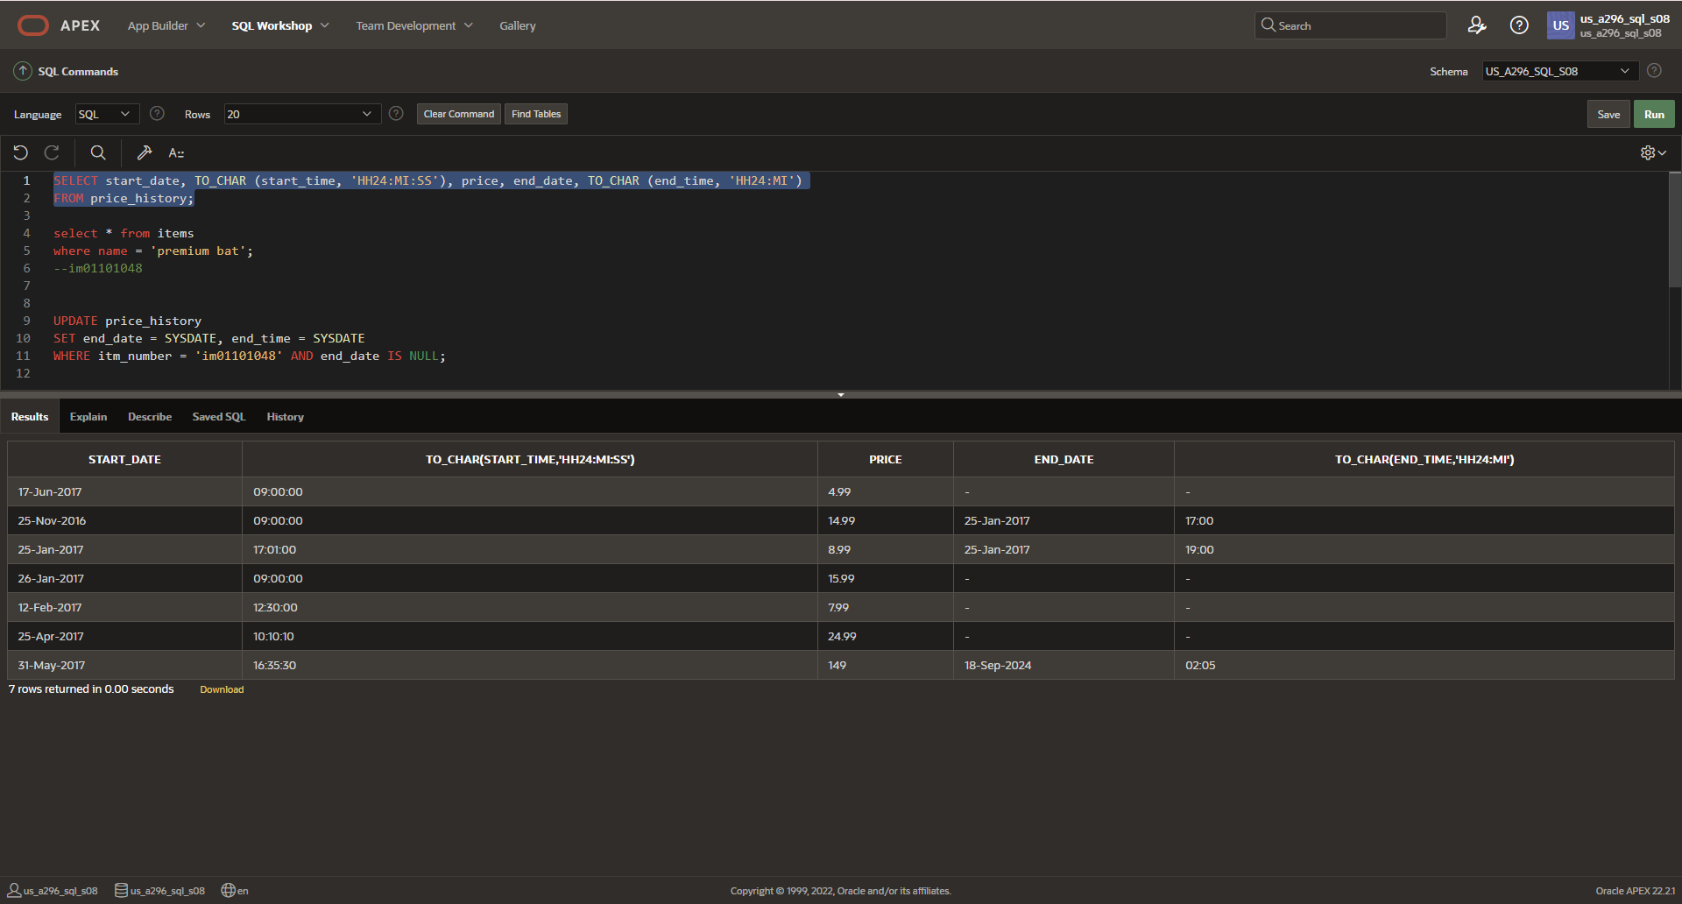

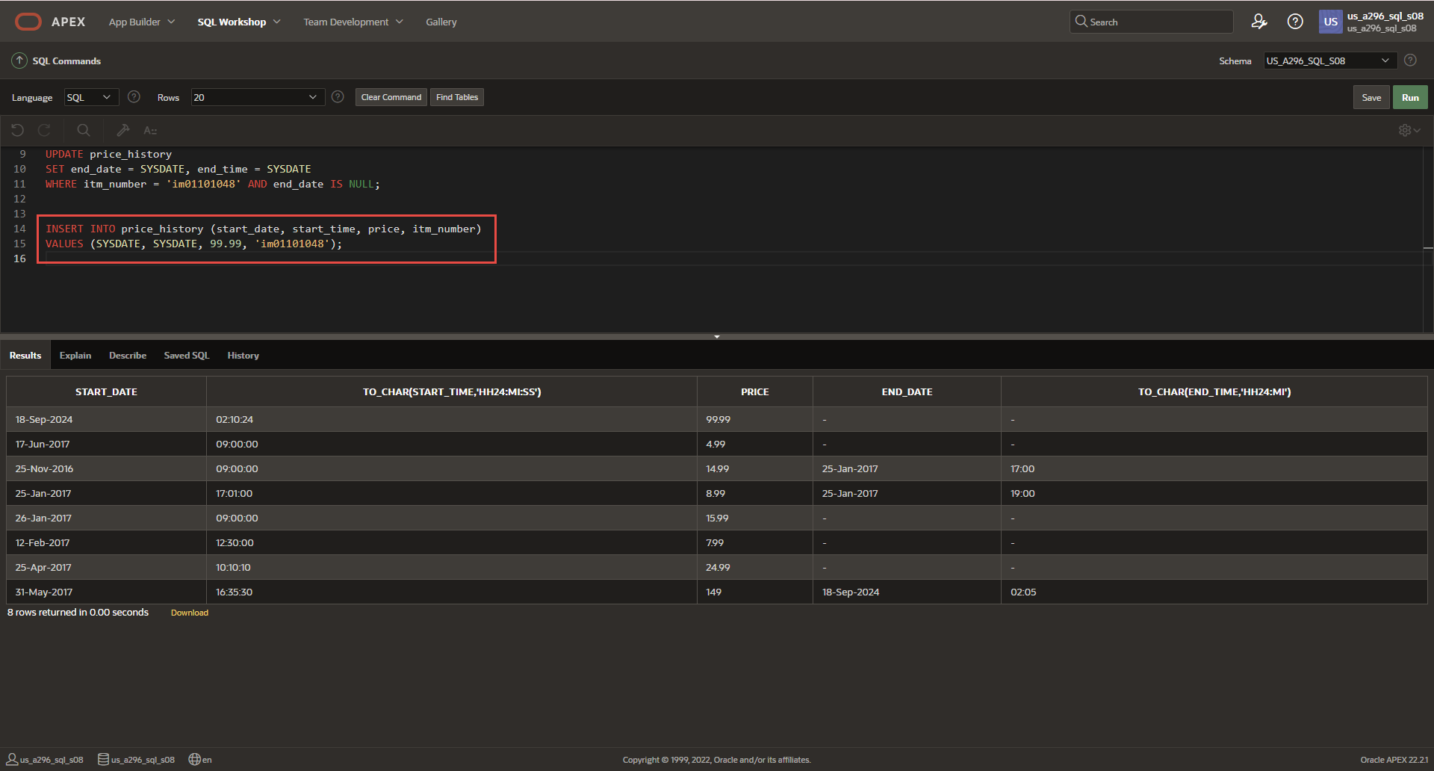

*Part 2*

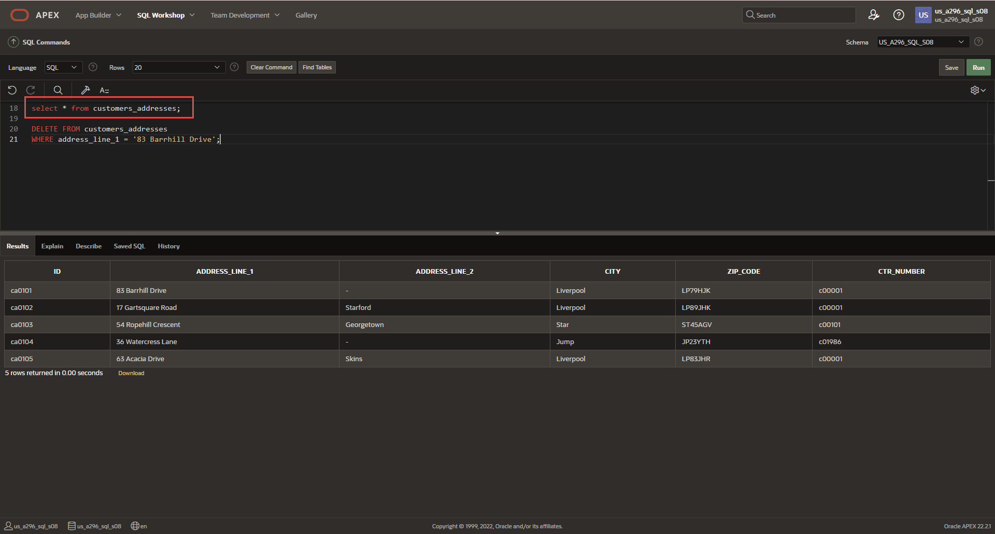

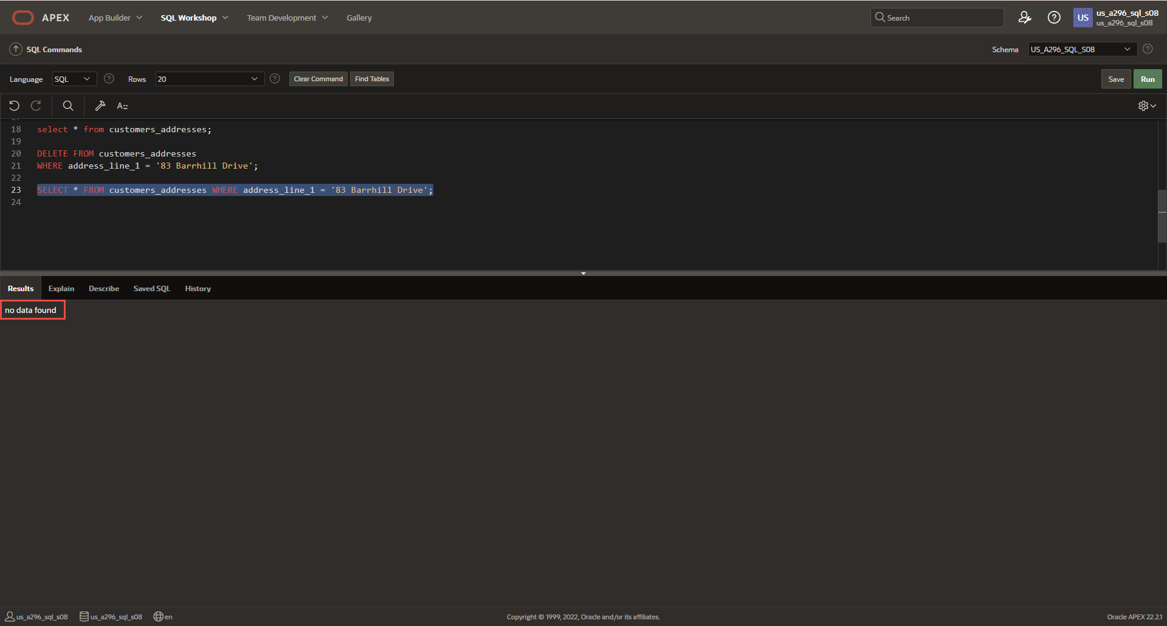

**DFo_6_6_1_Project**

**Question**:

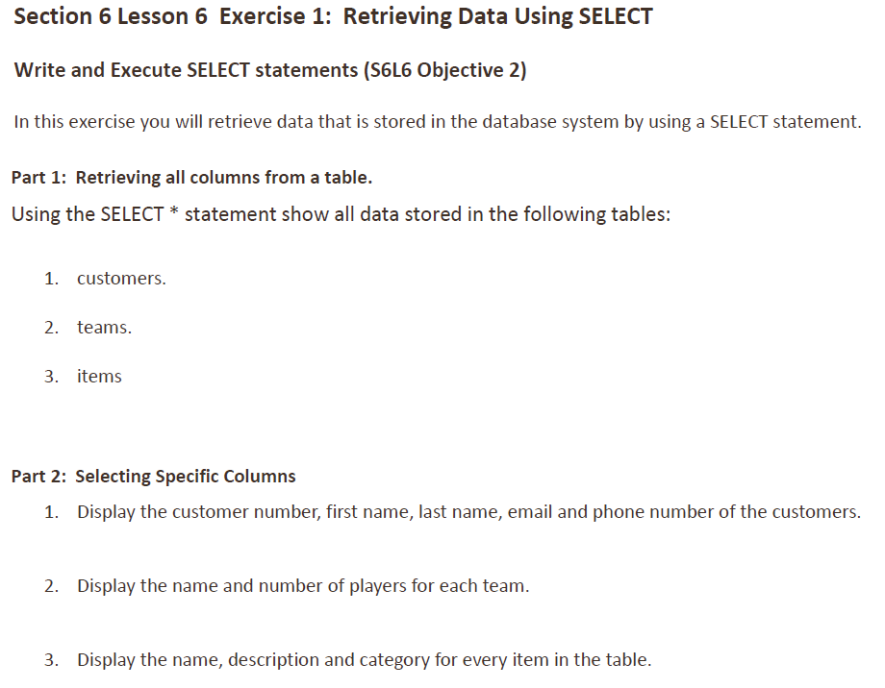

**Answers**:

*Part 1*

1. Customers

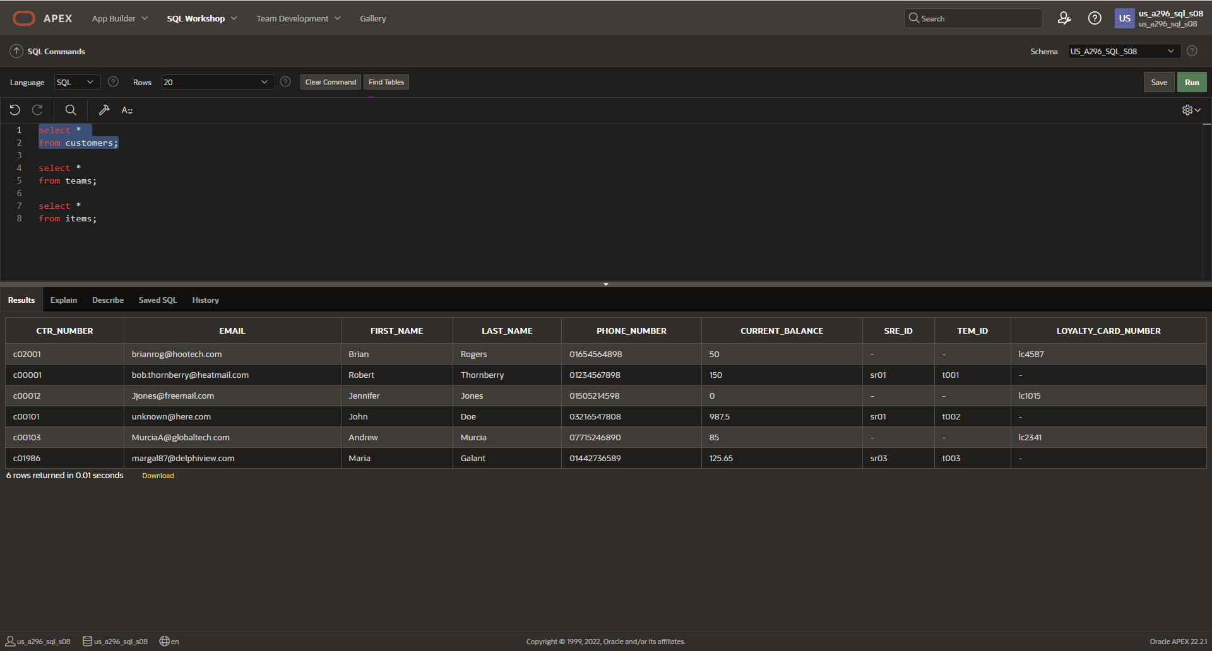

1. Teams

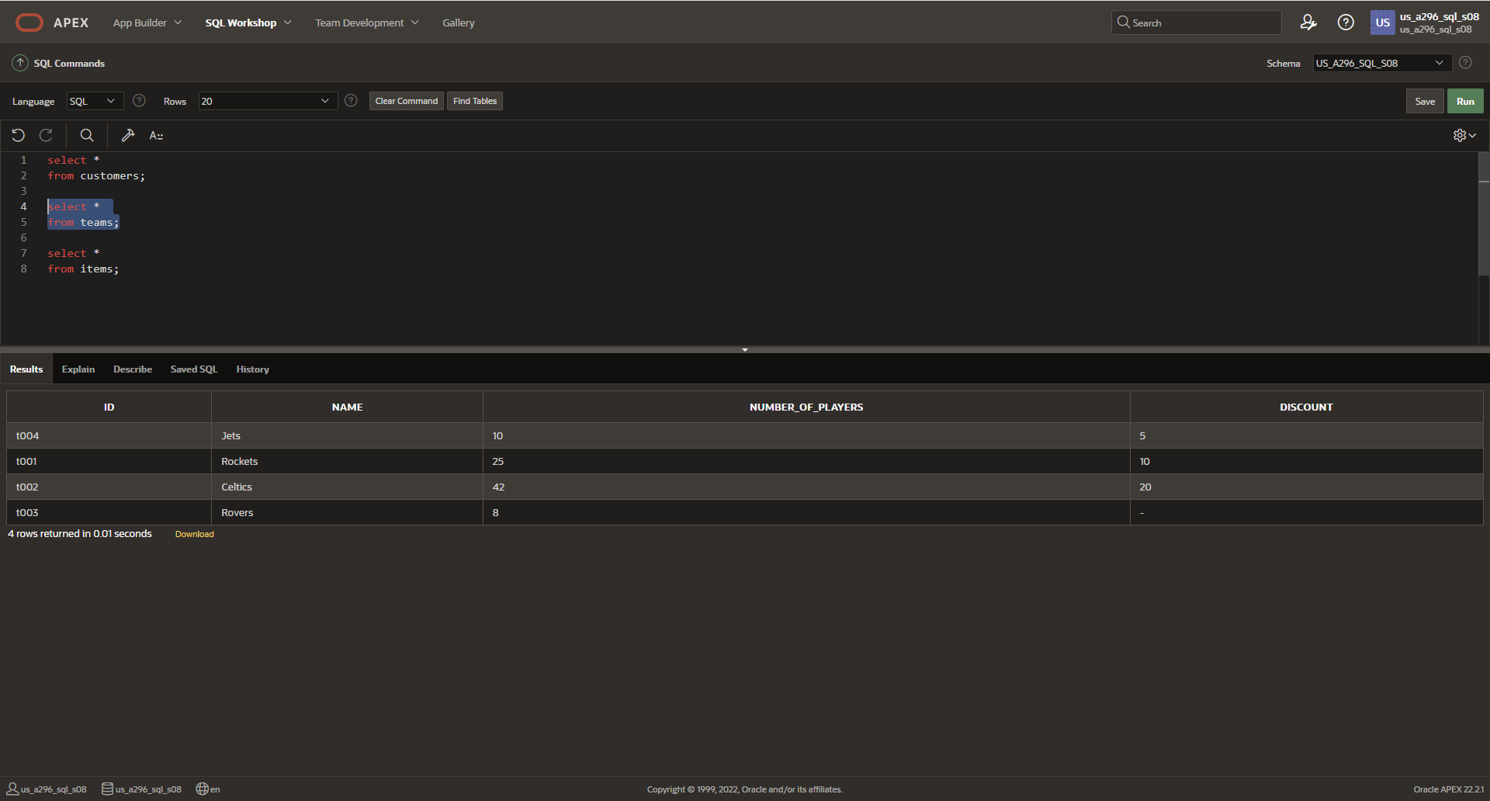

1. Items

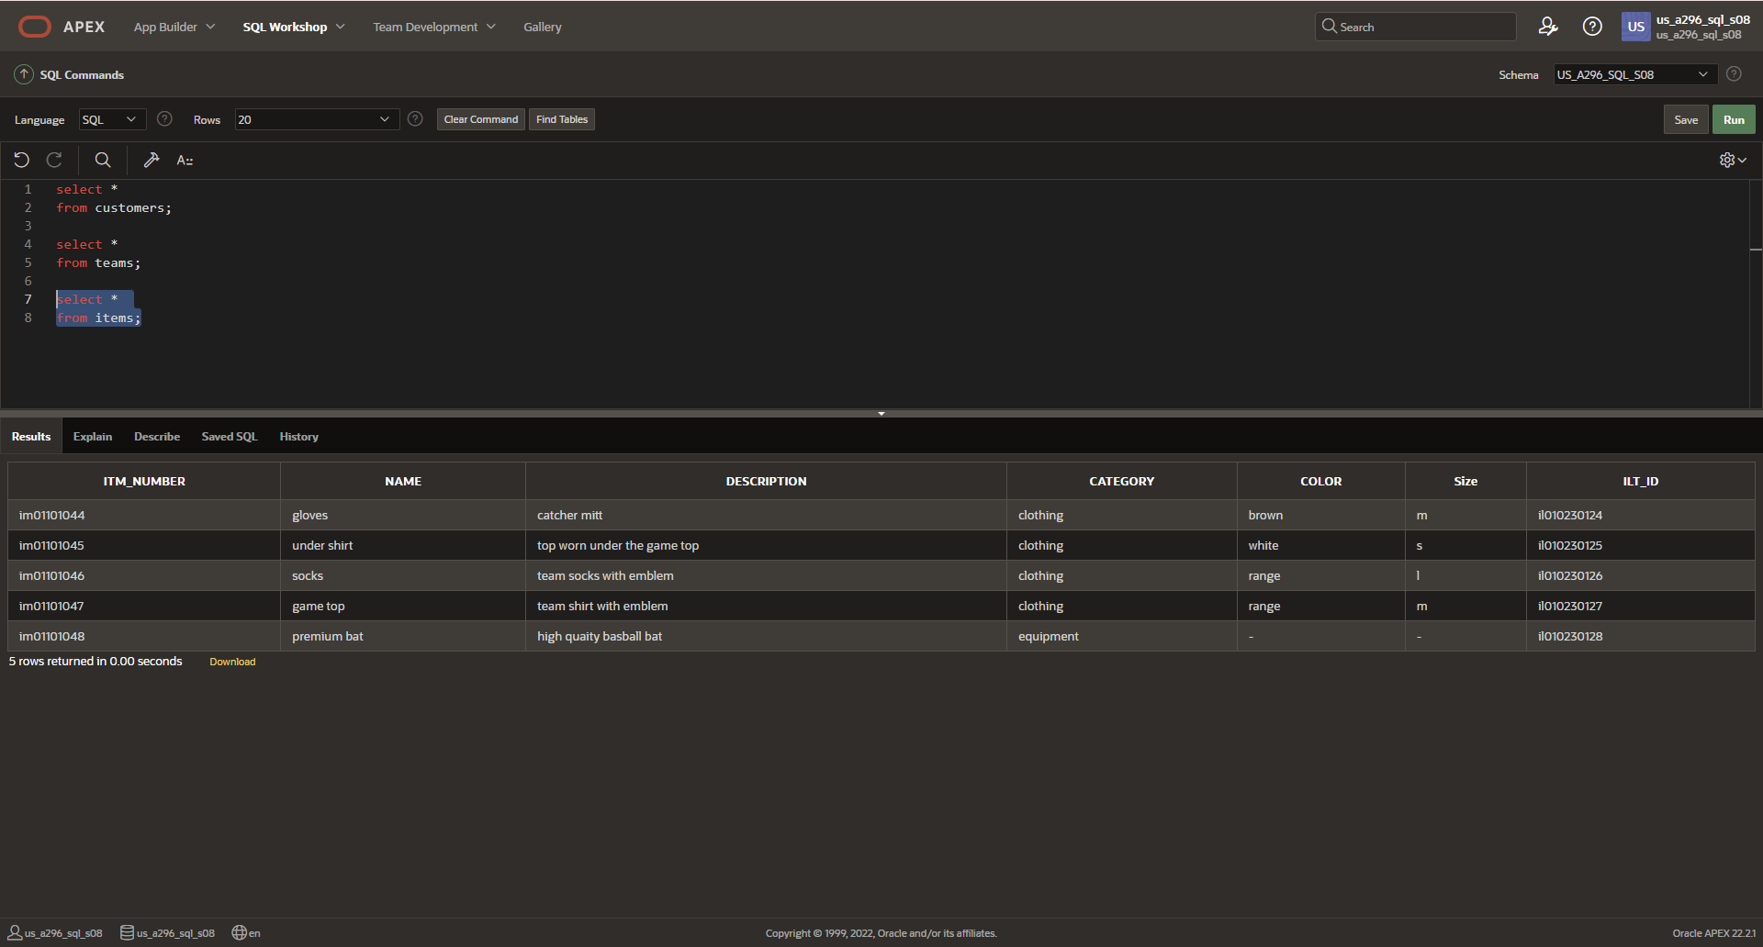

*Part 2*

1. Display customer number, first name, last name, email, and phone number from the customers table:

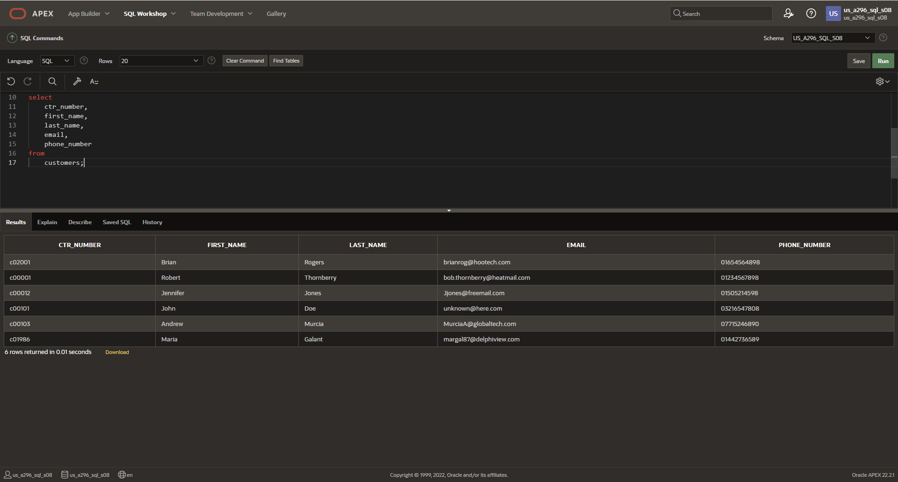

1. Display the name and number of players for each team

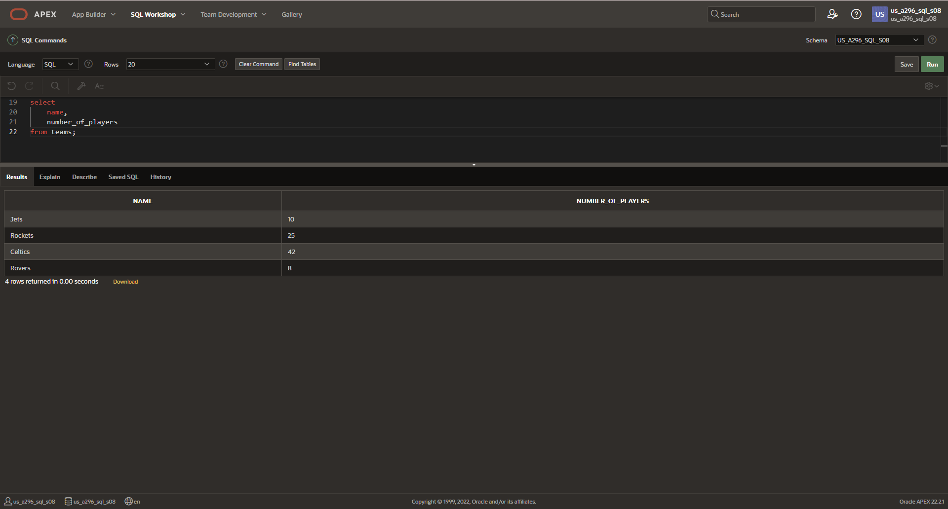

1. Display the name, description, and category for every item in the table

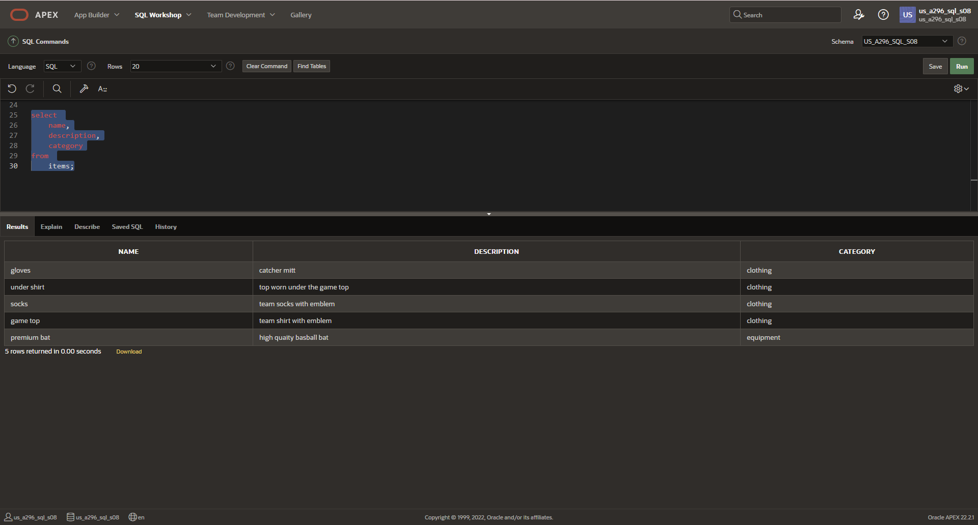

**DFo_6_6_2_Project**

**Questions**:

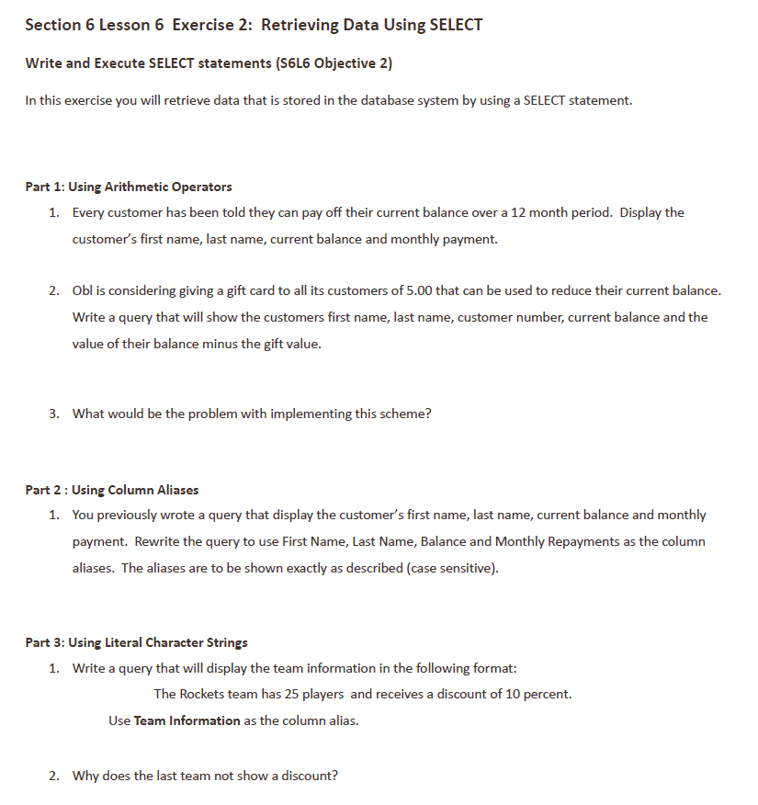

**Answers**:

*Part 1*

1. Display the customer’s first name, last name, current balance, and monthly payment

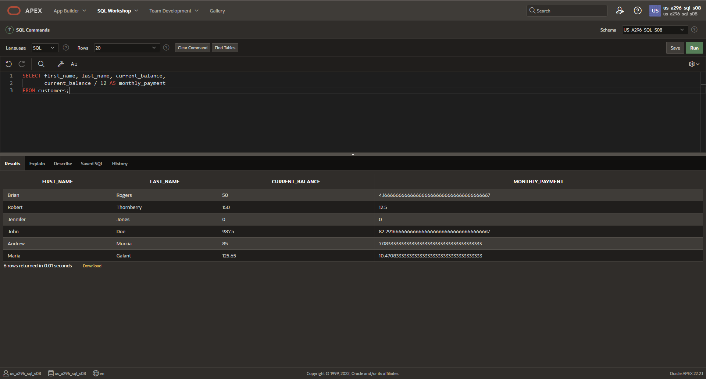

1. Gift card = $5

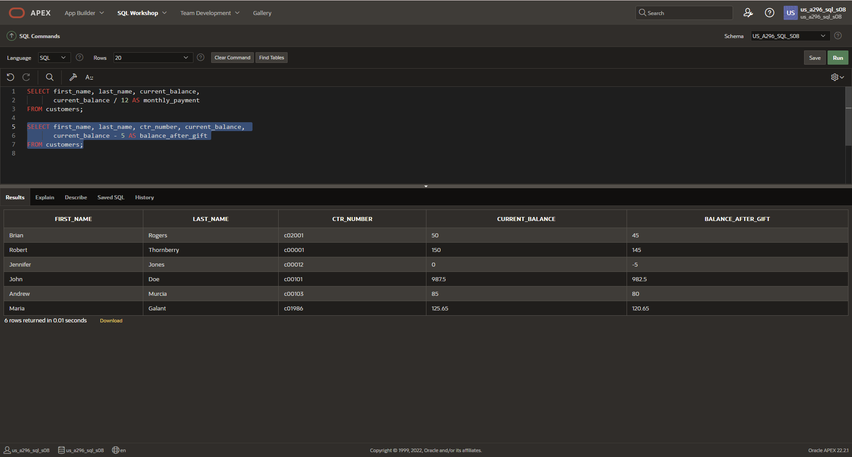

1. Problem?

The scheme could result in negative balances for customers whose current balance is less than $5.00. This could violate any check constraints ensuring the balance is non-negative, and it might not be logical from a business perspective to give customers more credit than they owe.

*Part 2*

1. Aliases

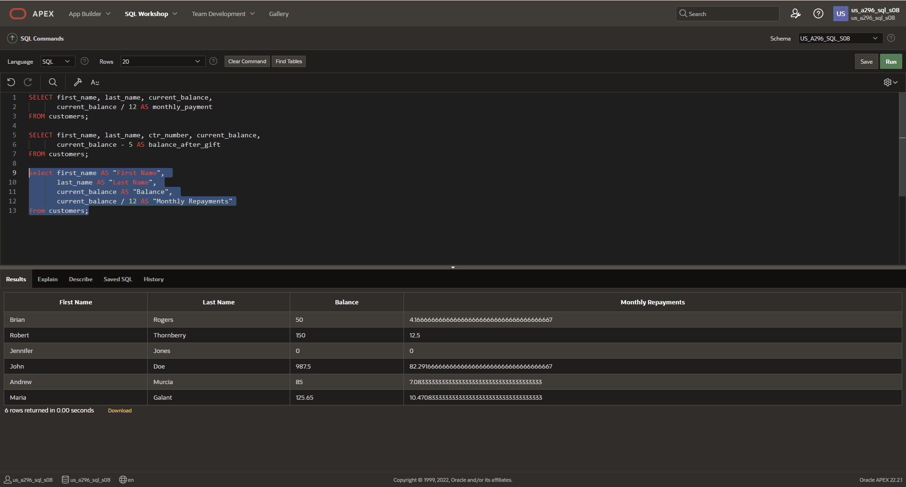

*Part 3*

1. Team Information

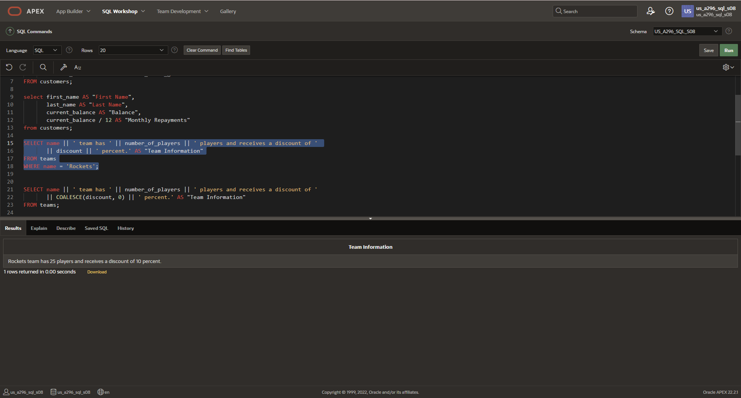

1. The discount column might contain a NULL value for the last team. When concatenating NULL with other values in SQL, the result is NULL. This is likely why no discount is displayed for the last team. To handle this, you could use the COALESCE() function to replace NULL values with 0.

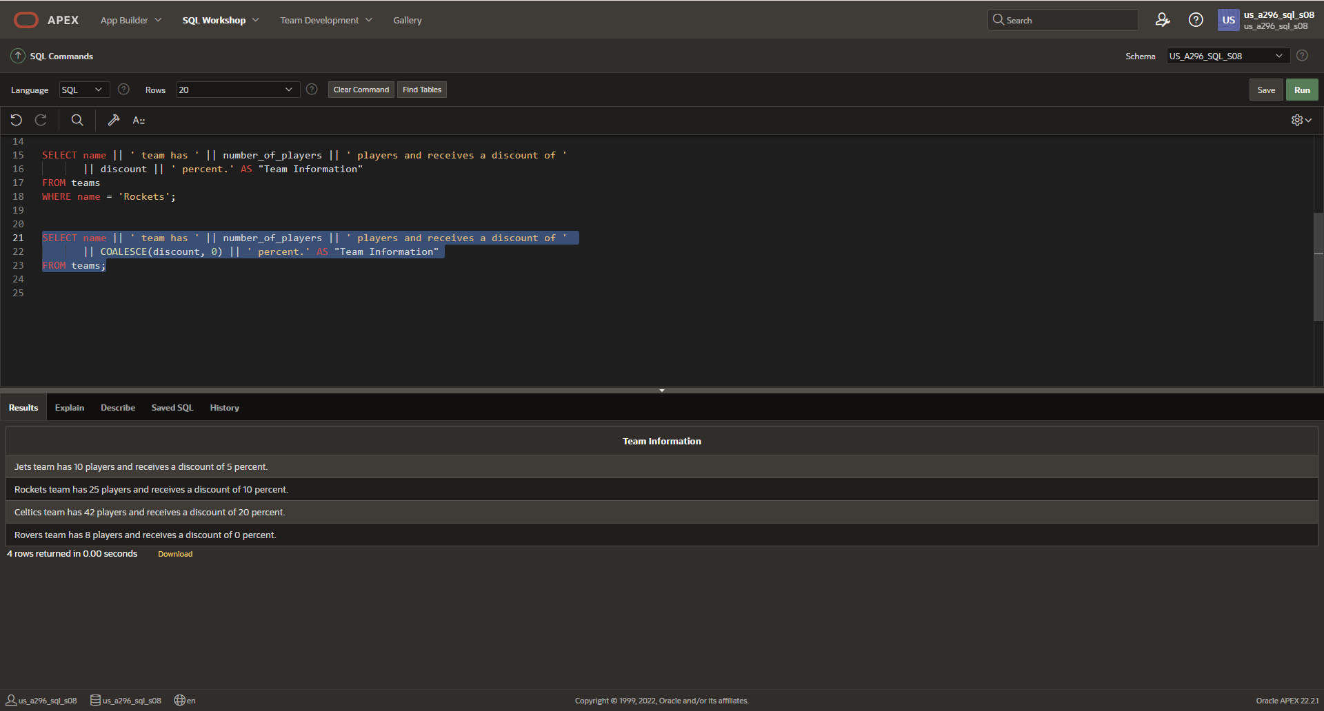

**DFo_6_7_1_Project**

**Questions**:

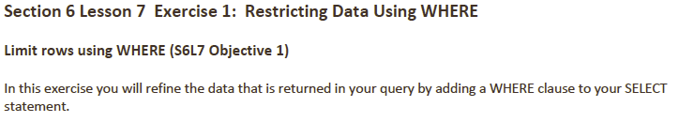

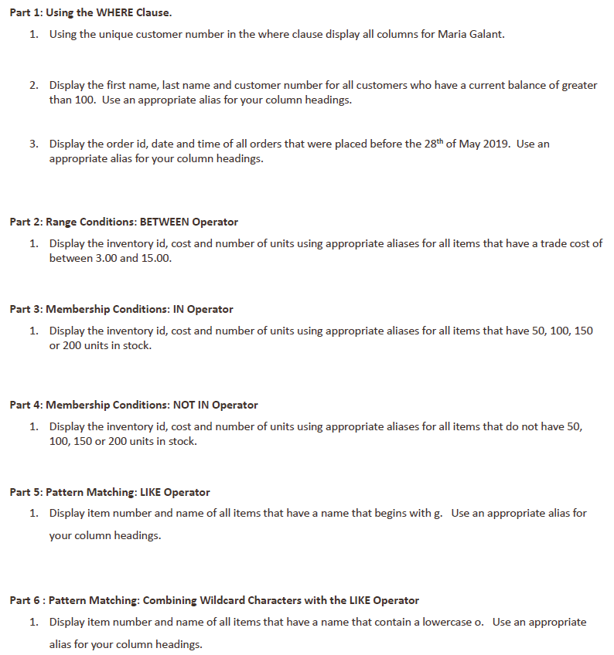

*Part 1*

1. Display all columns for Maria Galant using her unique customer number

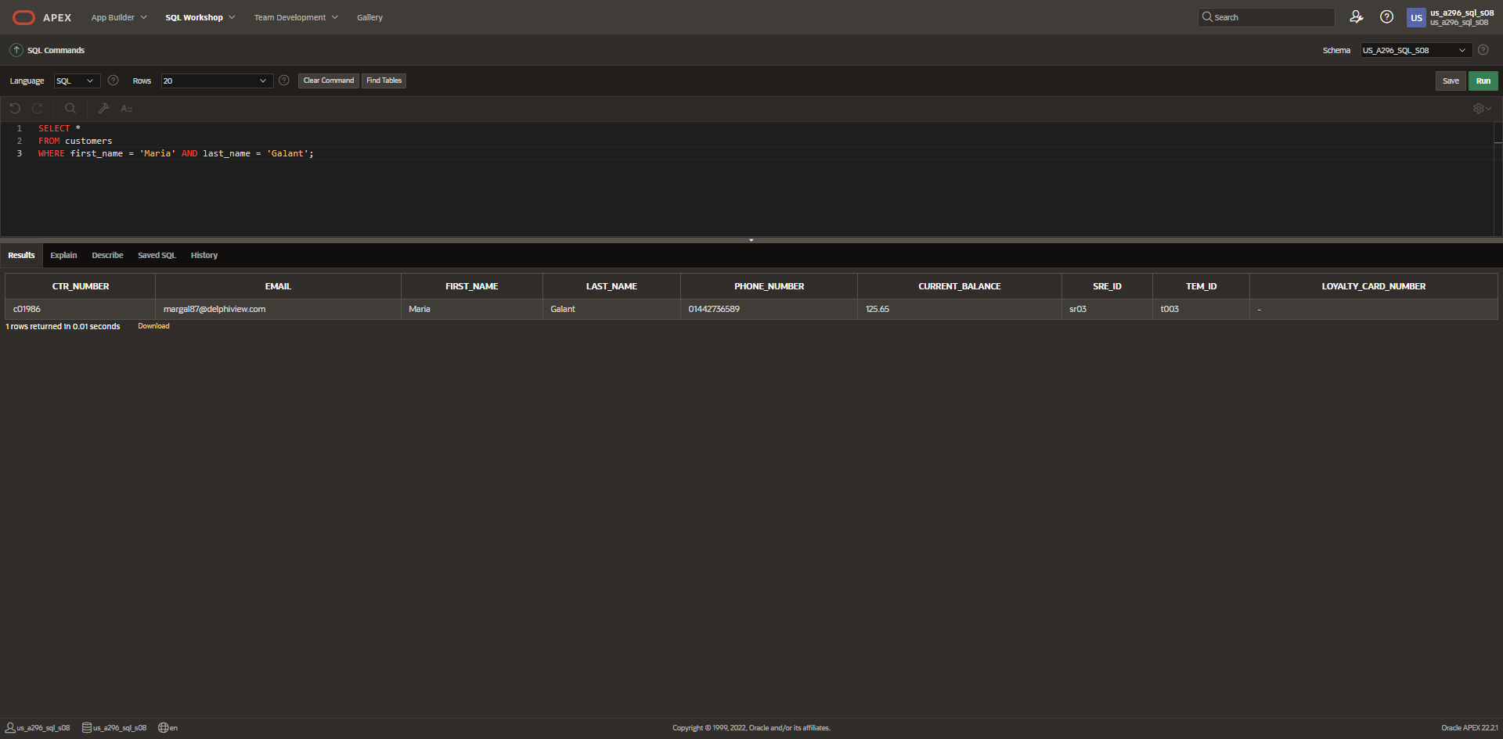

1. Display first name, last name, and customer number for customers with a current balance greater than 100

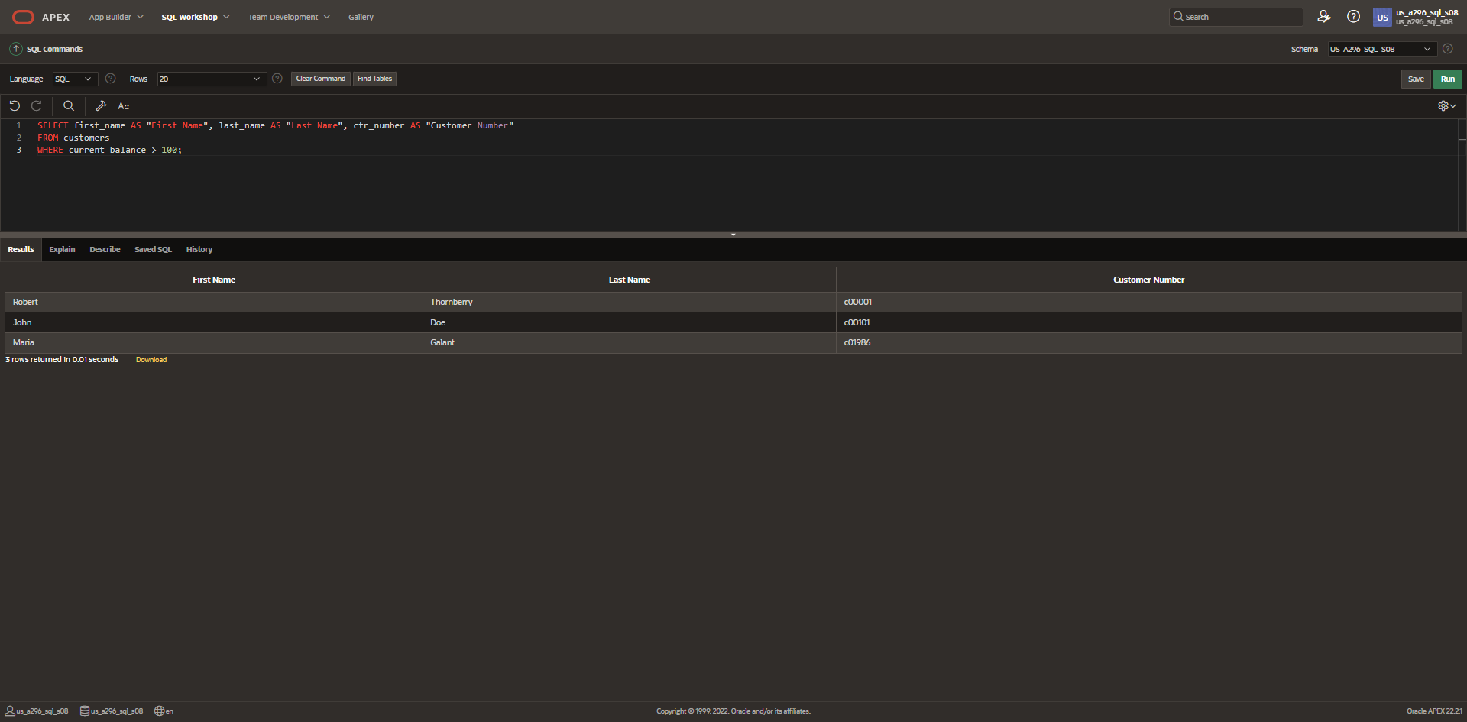

1. Display order id, date, and time for all orders placed before May 28, 2019

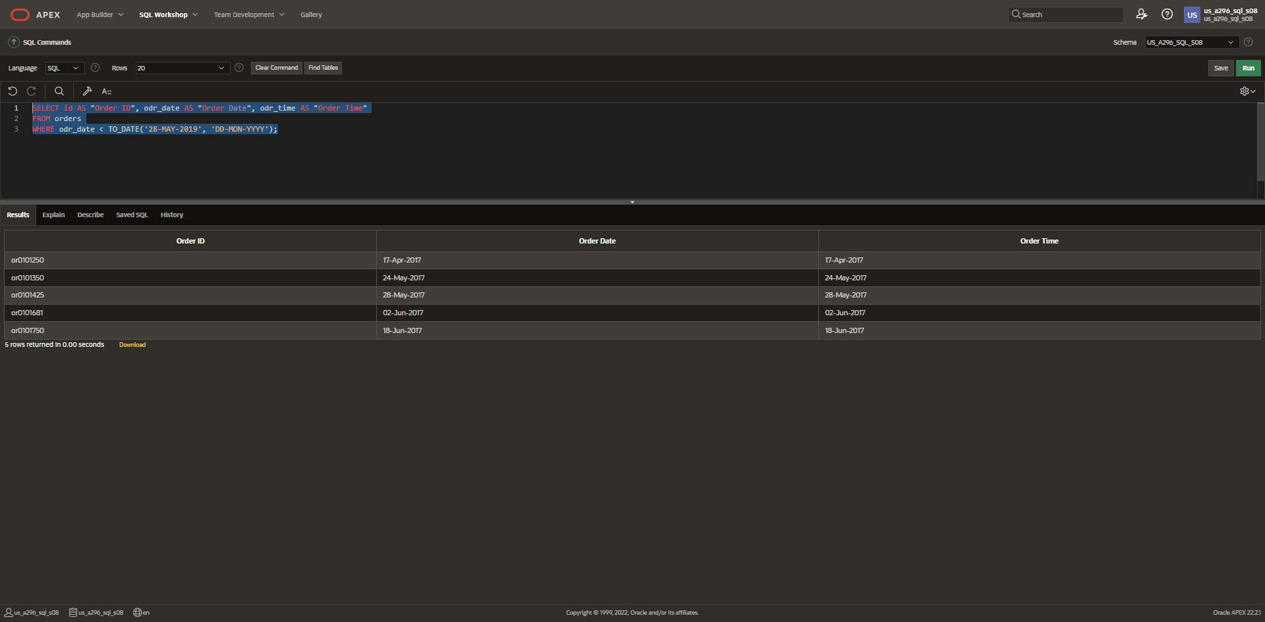

*Part 2*

1. Between operator

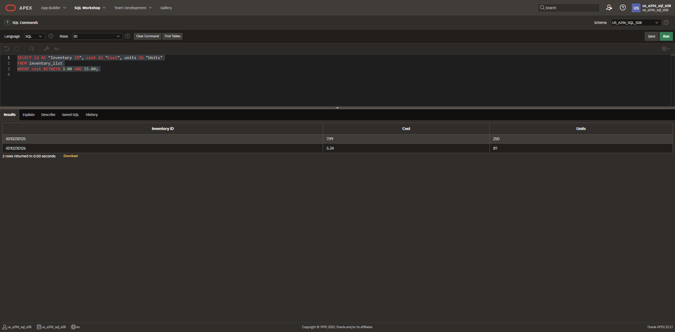

*Part 3*

1. IN operator

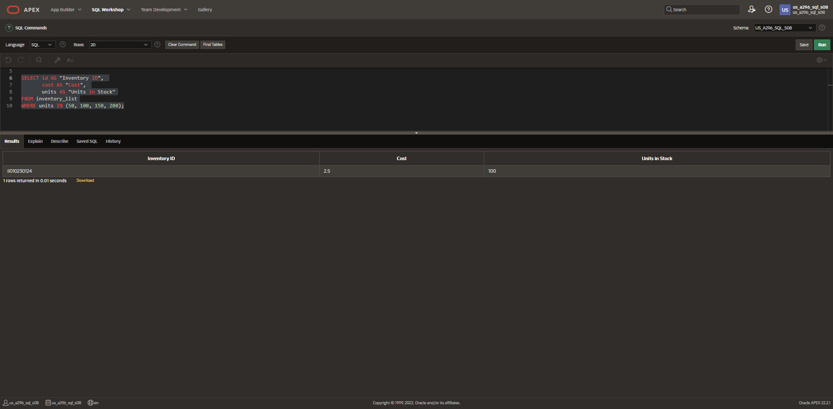

*Part 4*

1. NOT IN operator

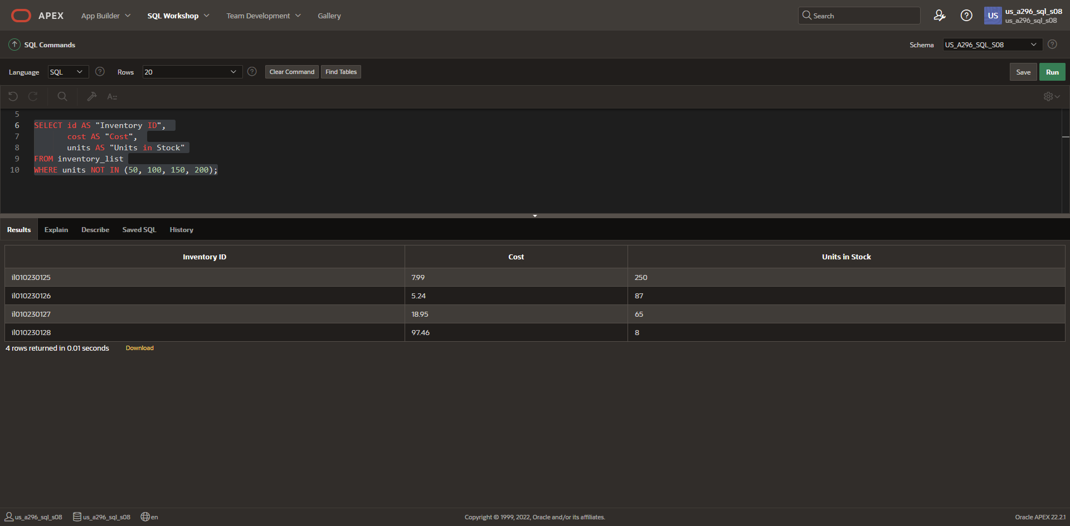

*Part 5*

1. LIKE operator

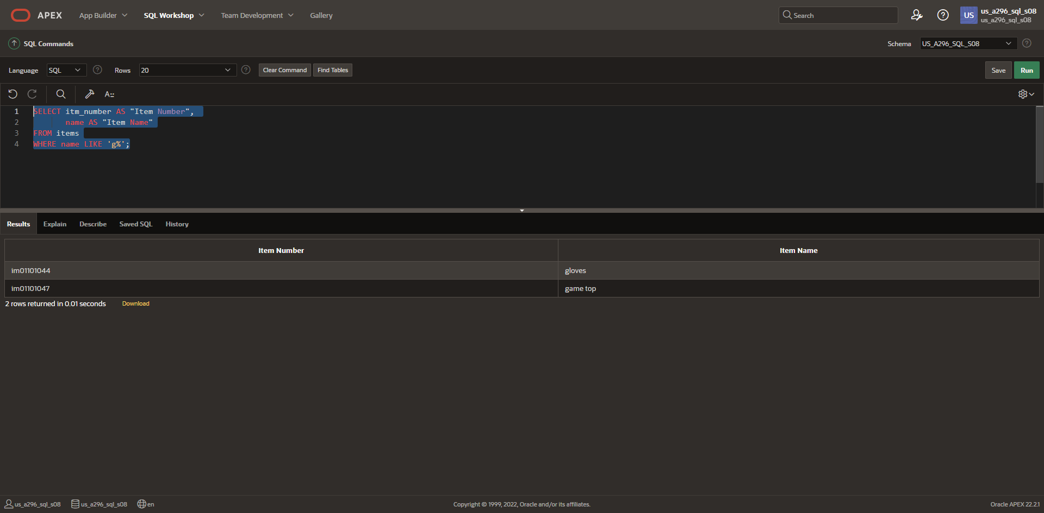

*Part 6*

1. LIKE operator with wildcards

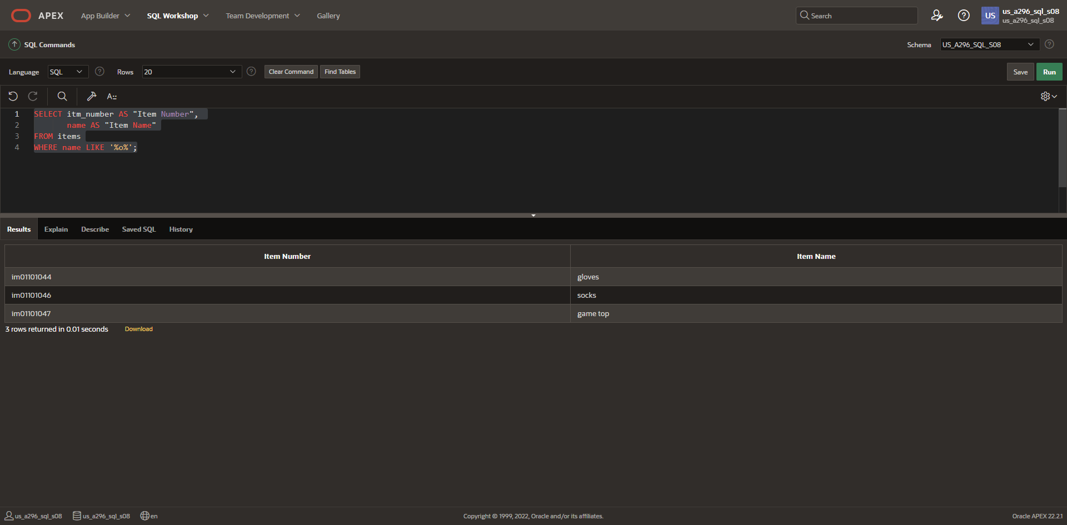

**DFo_6_7_2_ Project**

**Questions**:

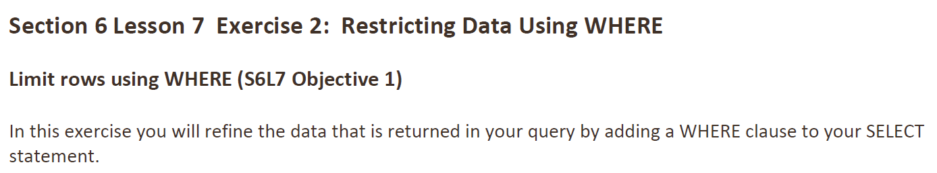

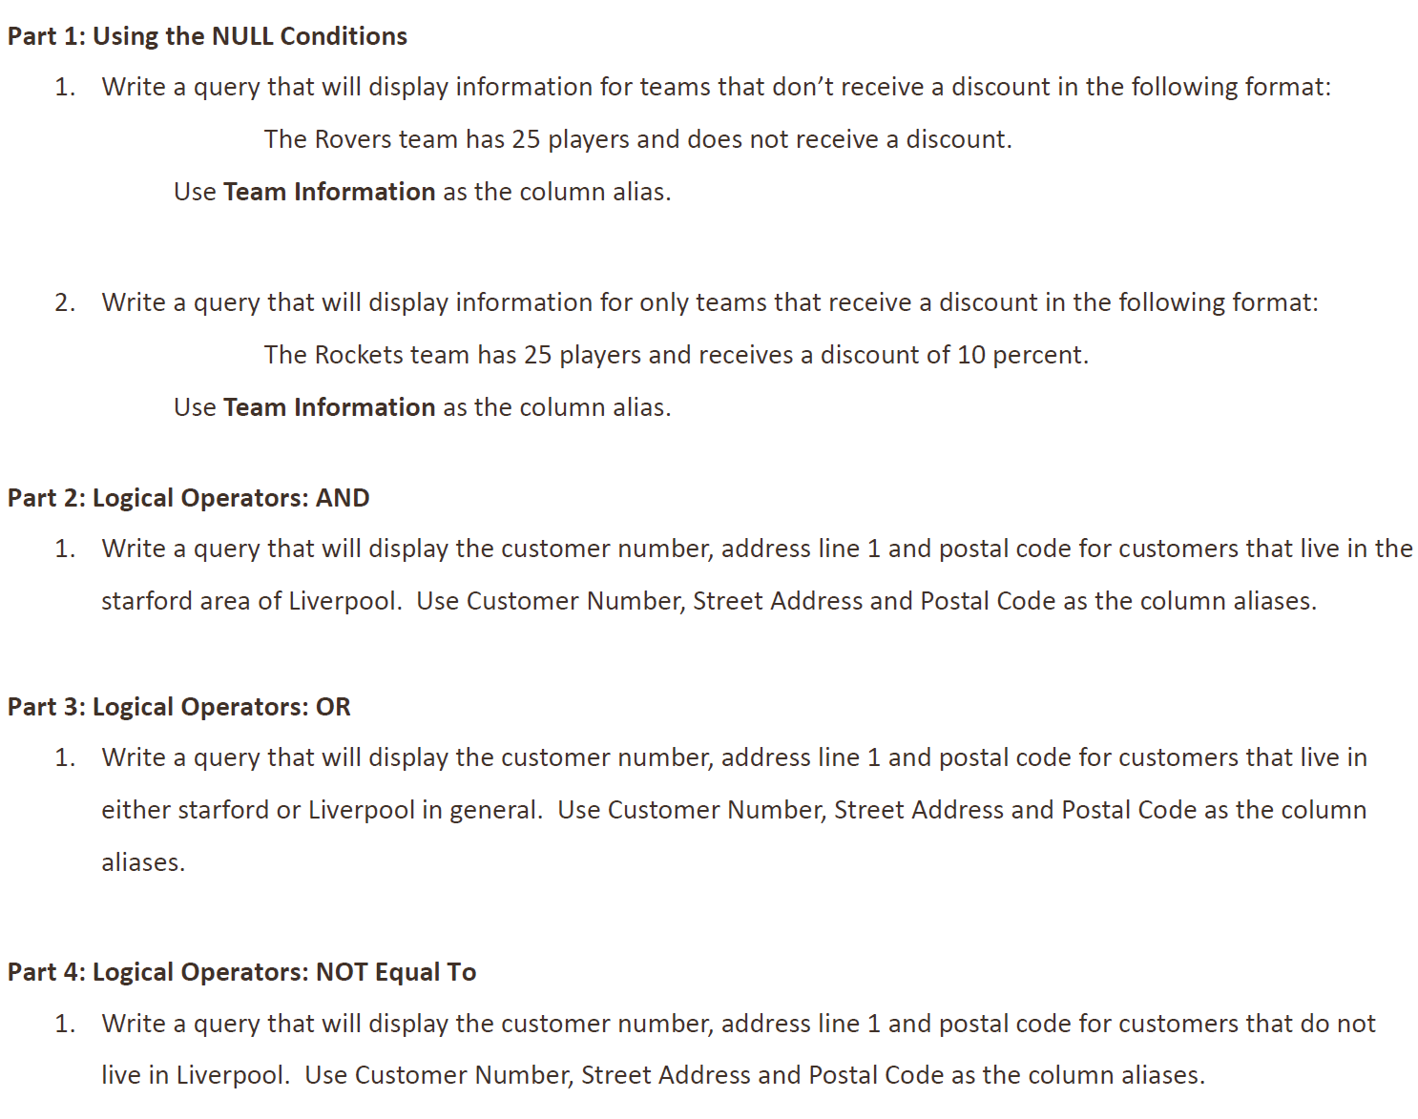

**Answers**:

*Part 1*

1. No discount

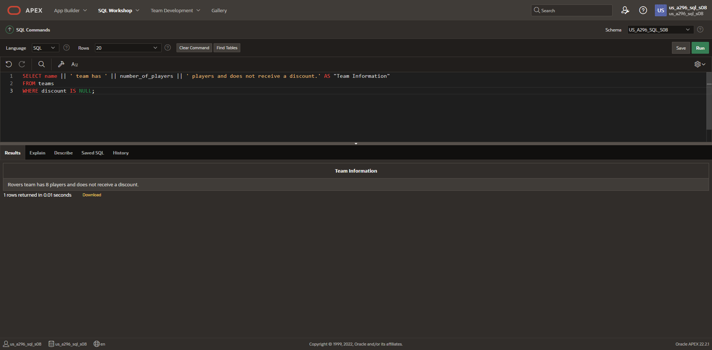

1. Greater than 0% discount

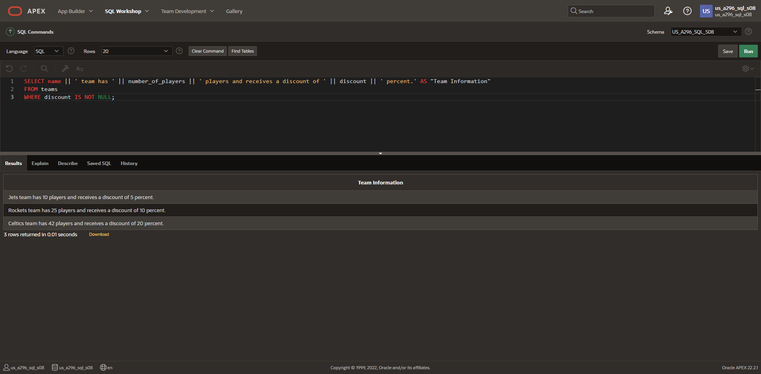

*Part 2*

1. AND operator

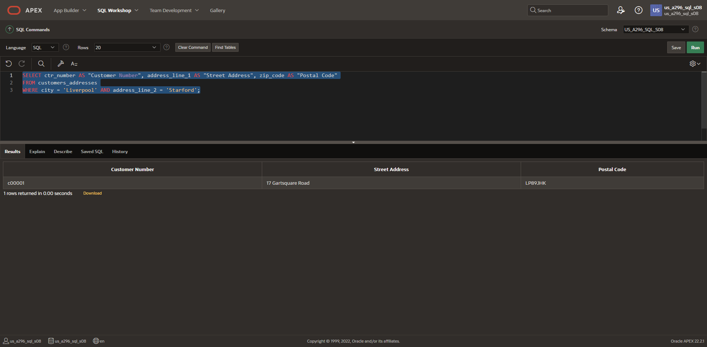

*Part 3*

1. OR operator

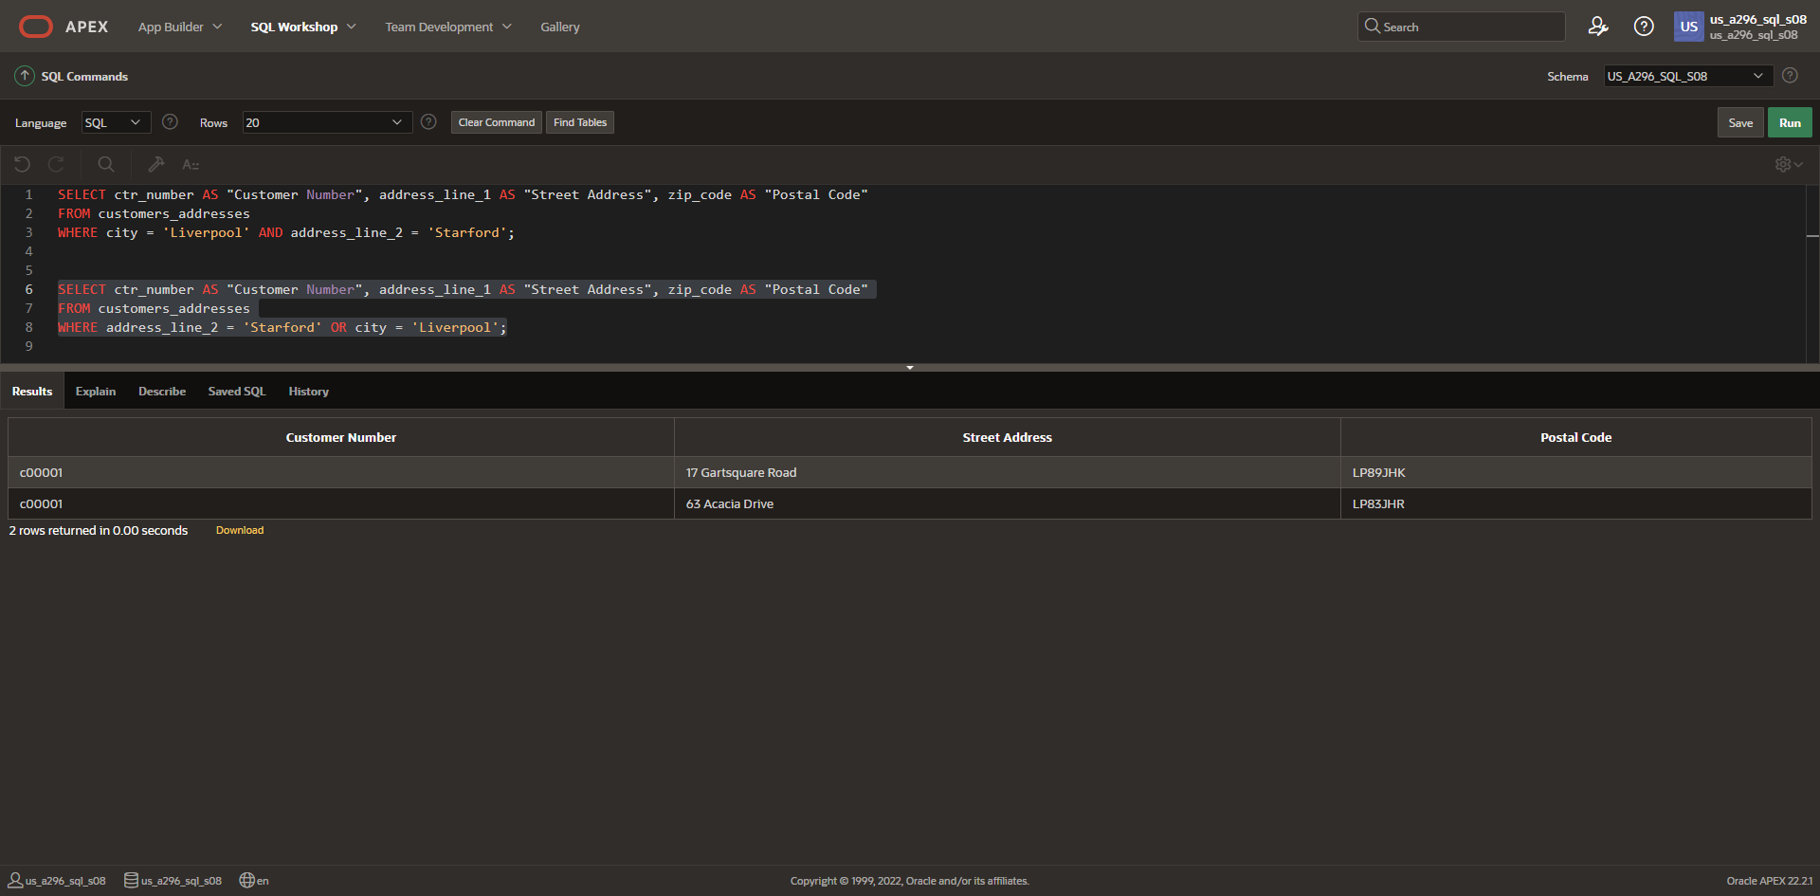

*Part 4*

1. NOT EQUAL TO operator

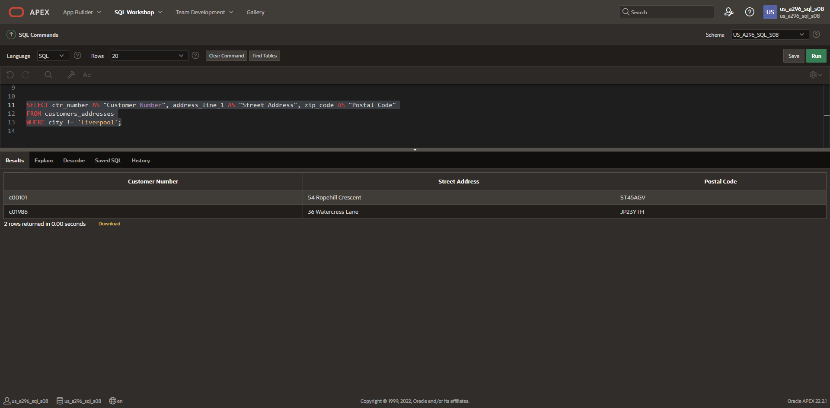

**DFo_6_8_1_Project**

**Questions**:

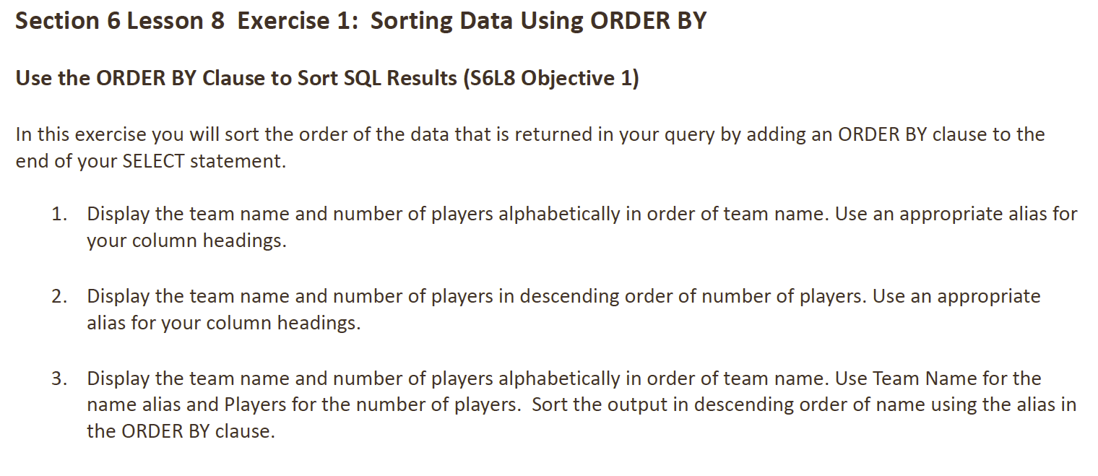

**Answers**:

1. Display alphabetically

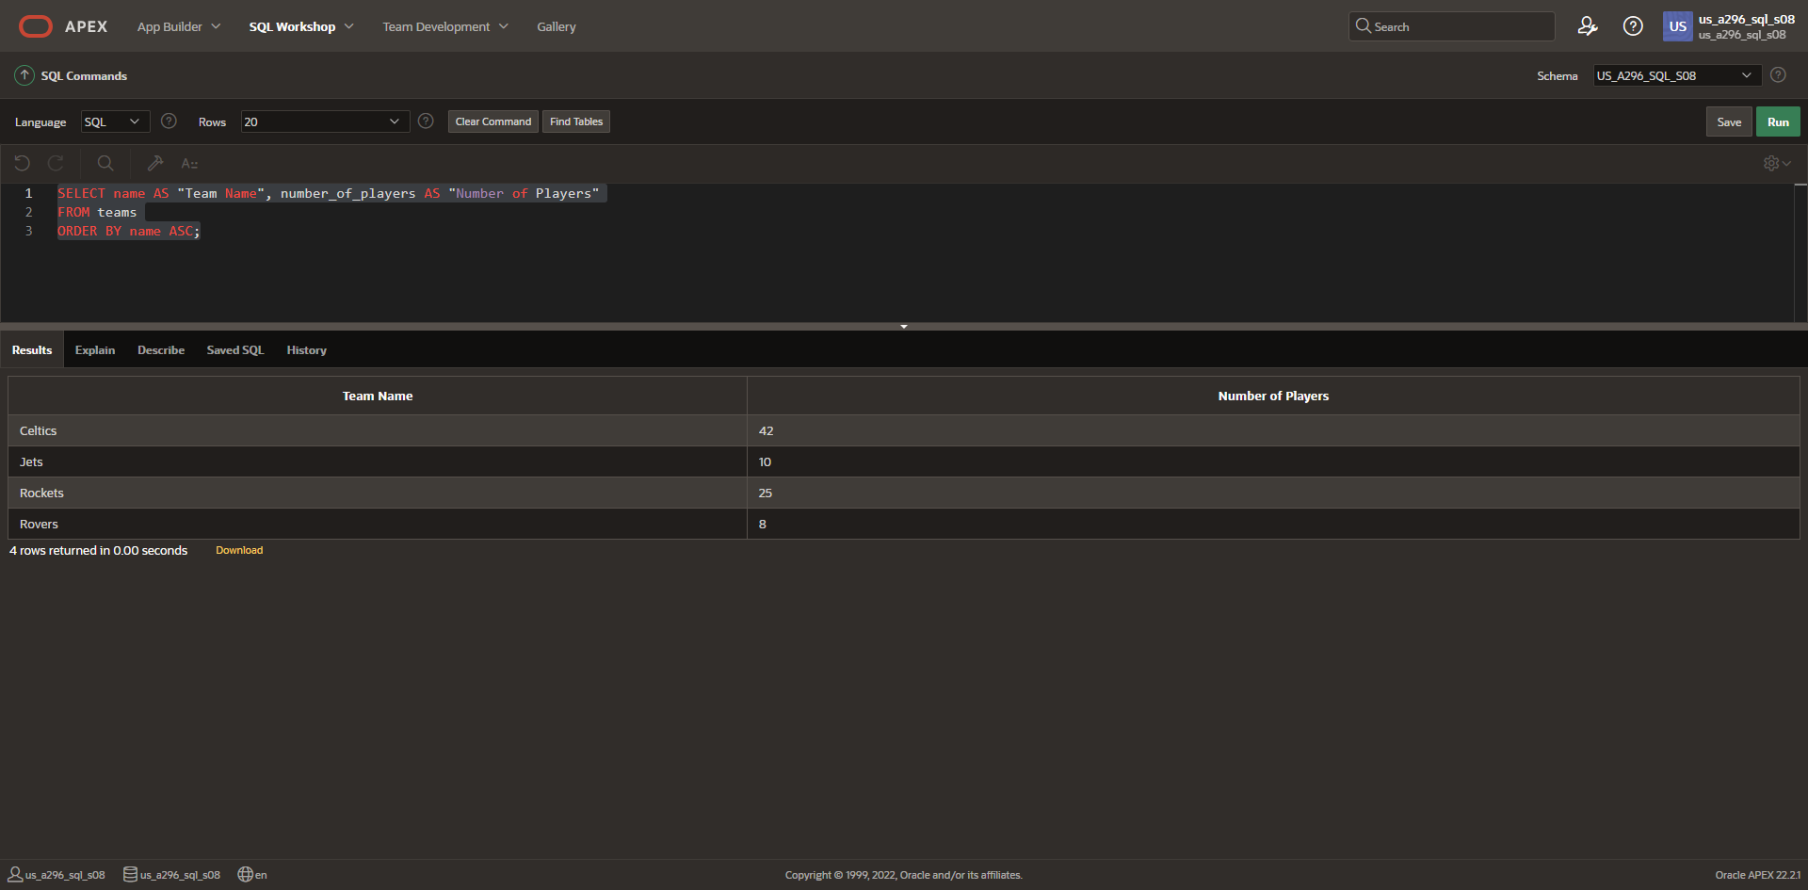

1. Descending order of number of players

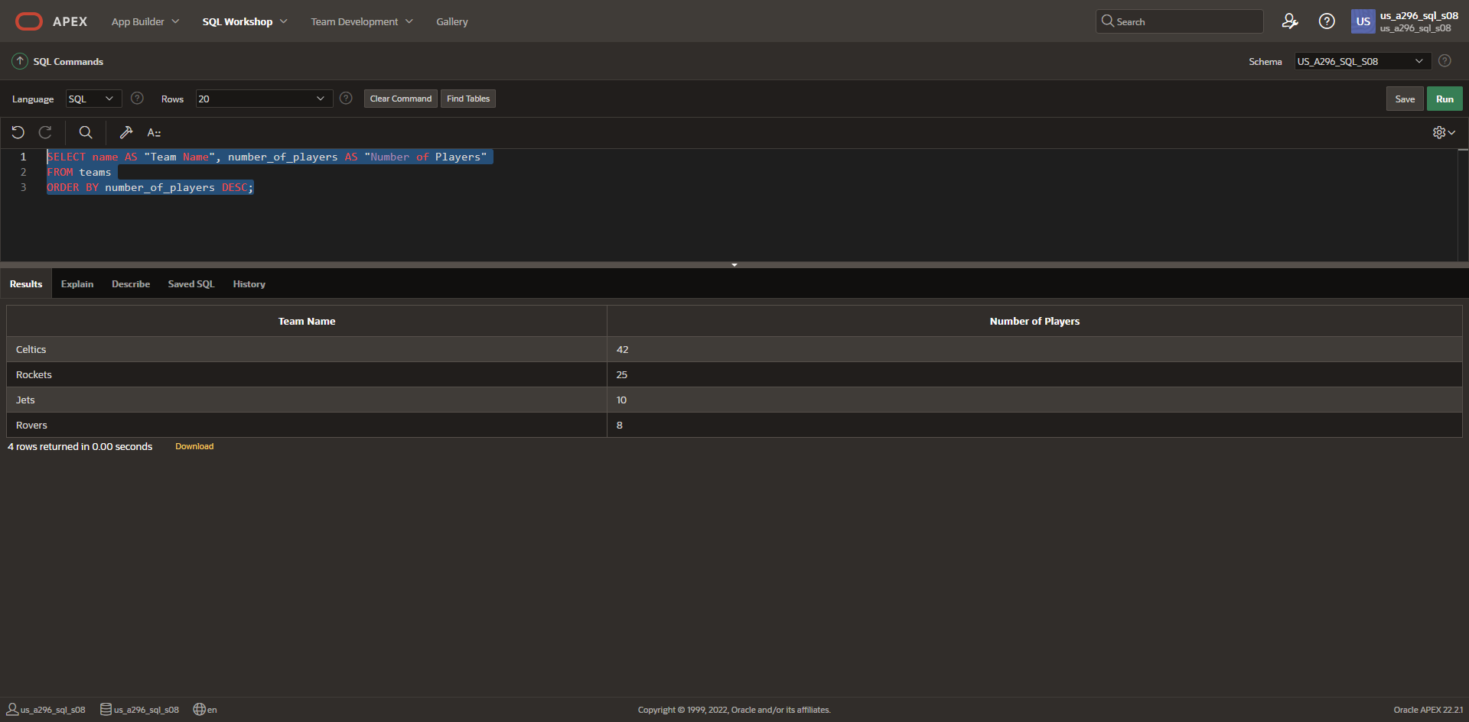

1. ORDER BY clause

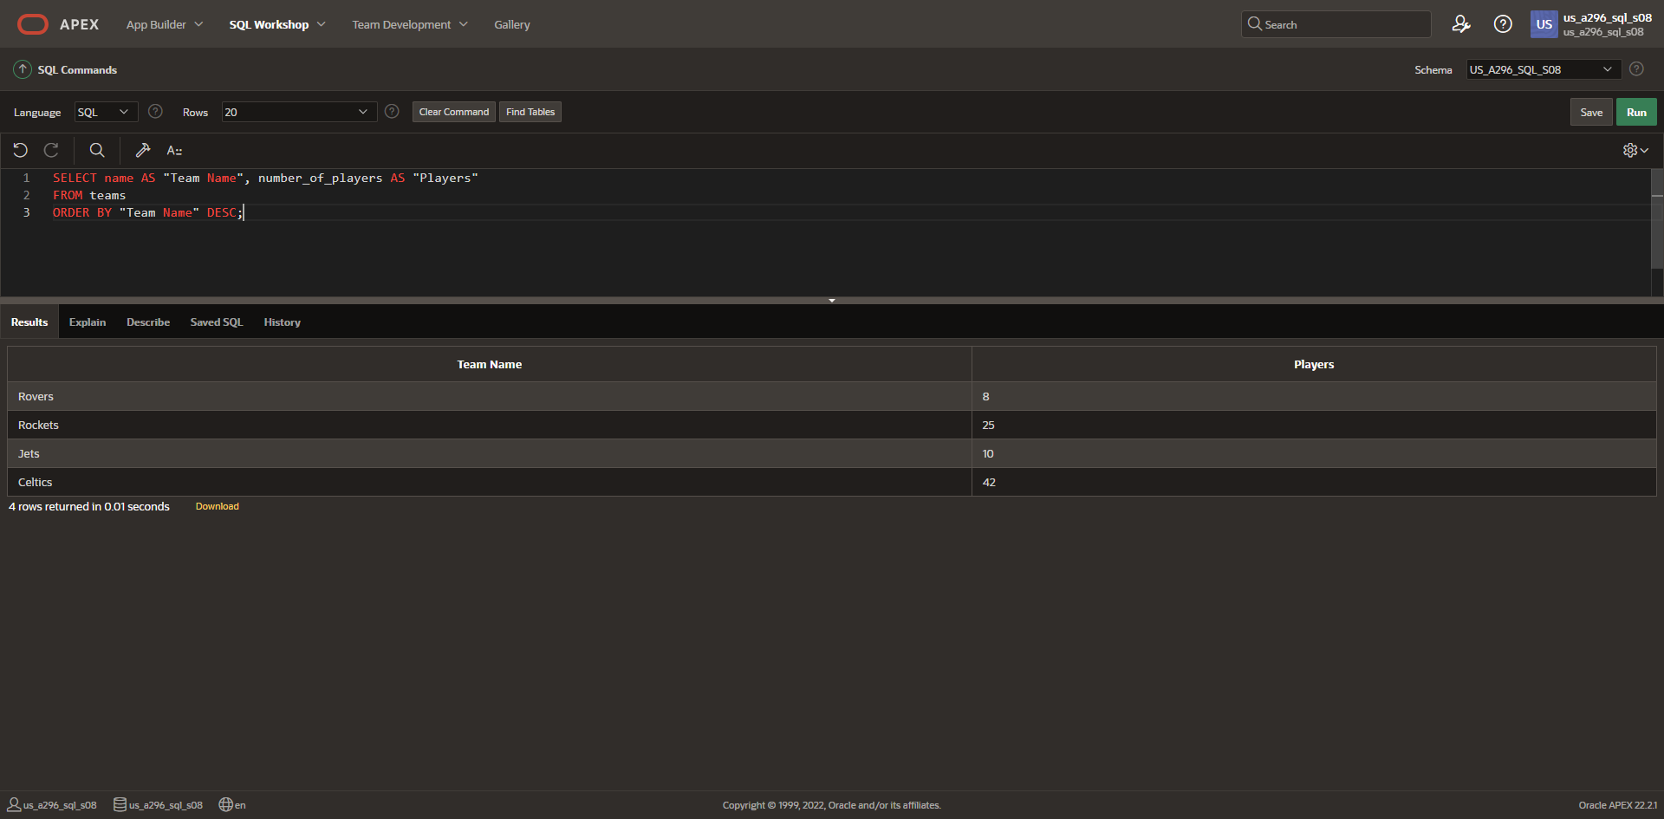

**DFo_6_8_2_Project**

**Questions**:

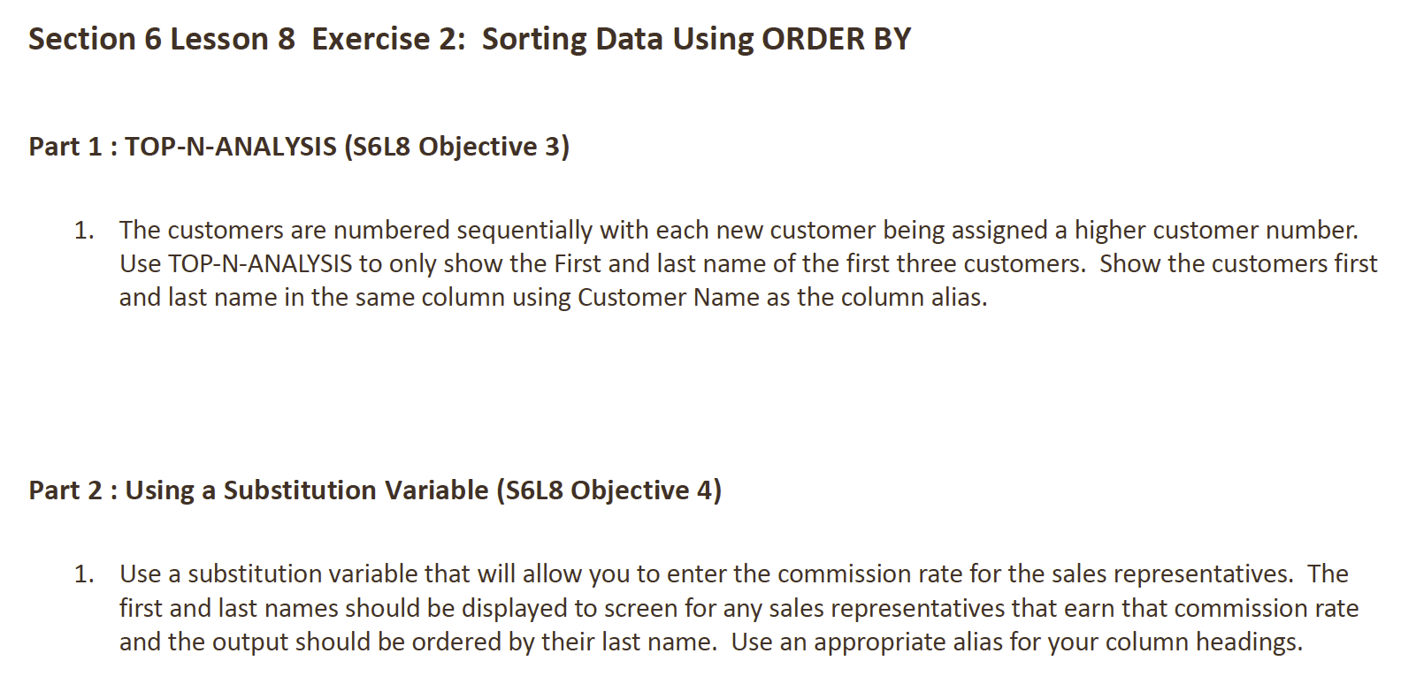

**Answers**:

*Part 1*

1. Top-N-Analysis

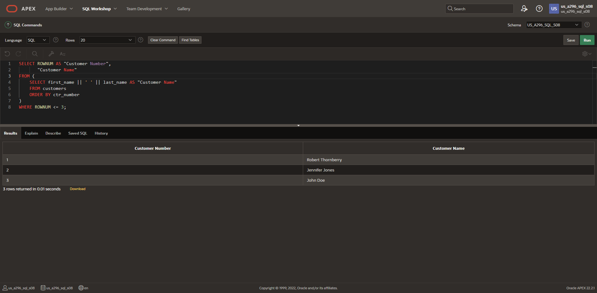

*Part 2*

1. Substitution variables

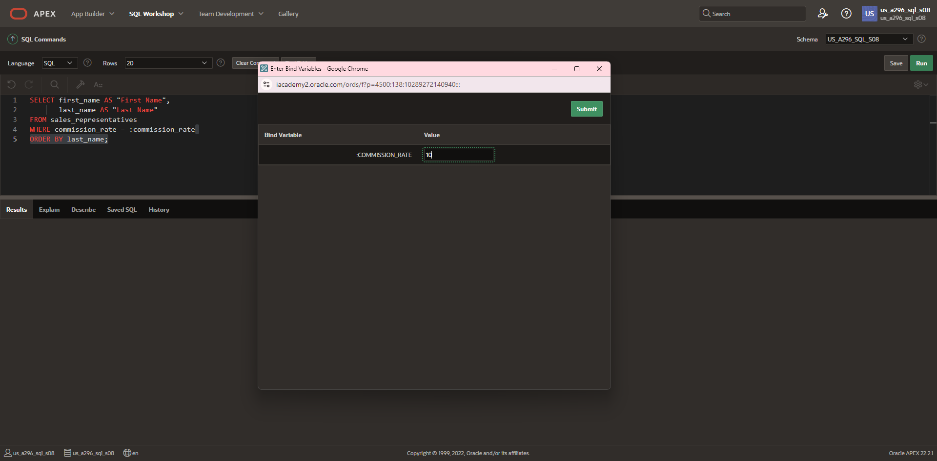

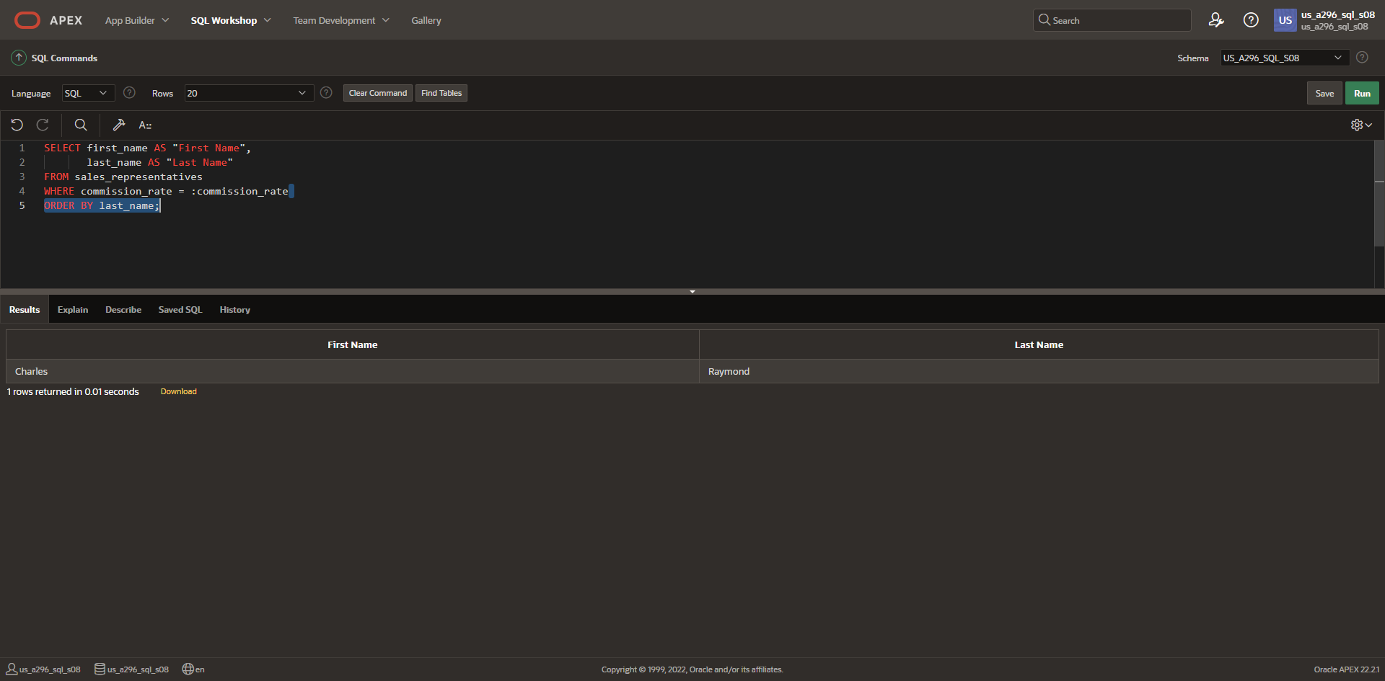

**DFo_6_9_1_Project**

**Questions**:

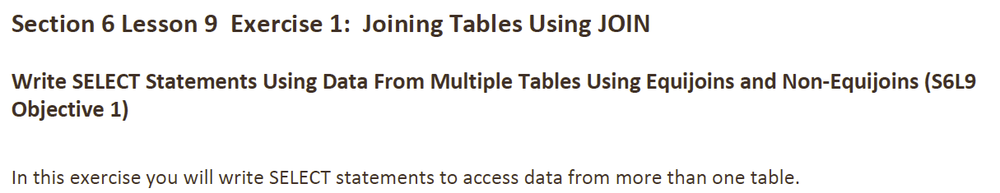

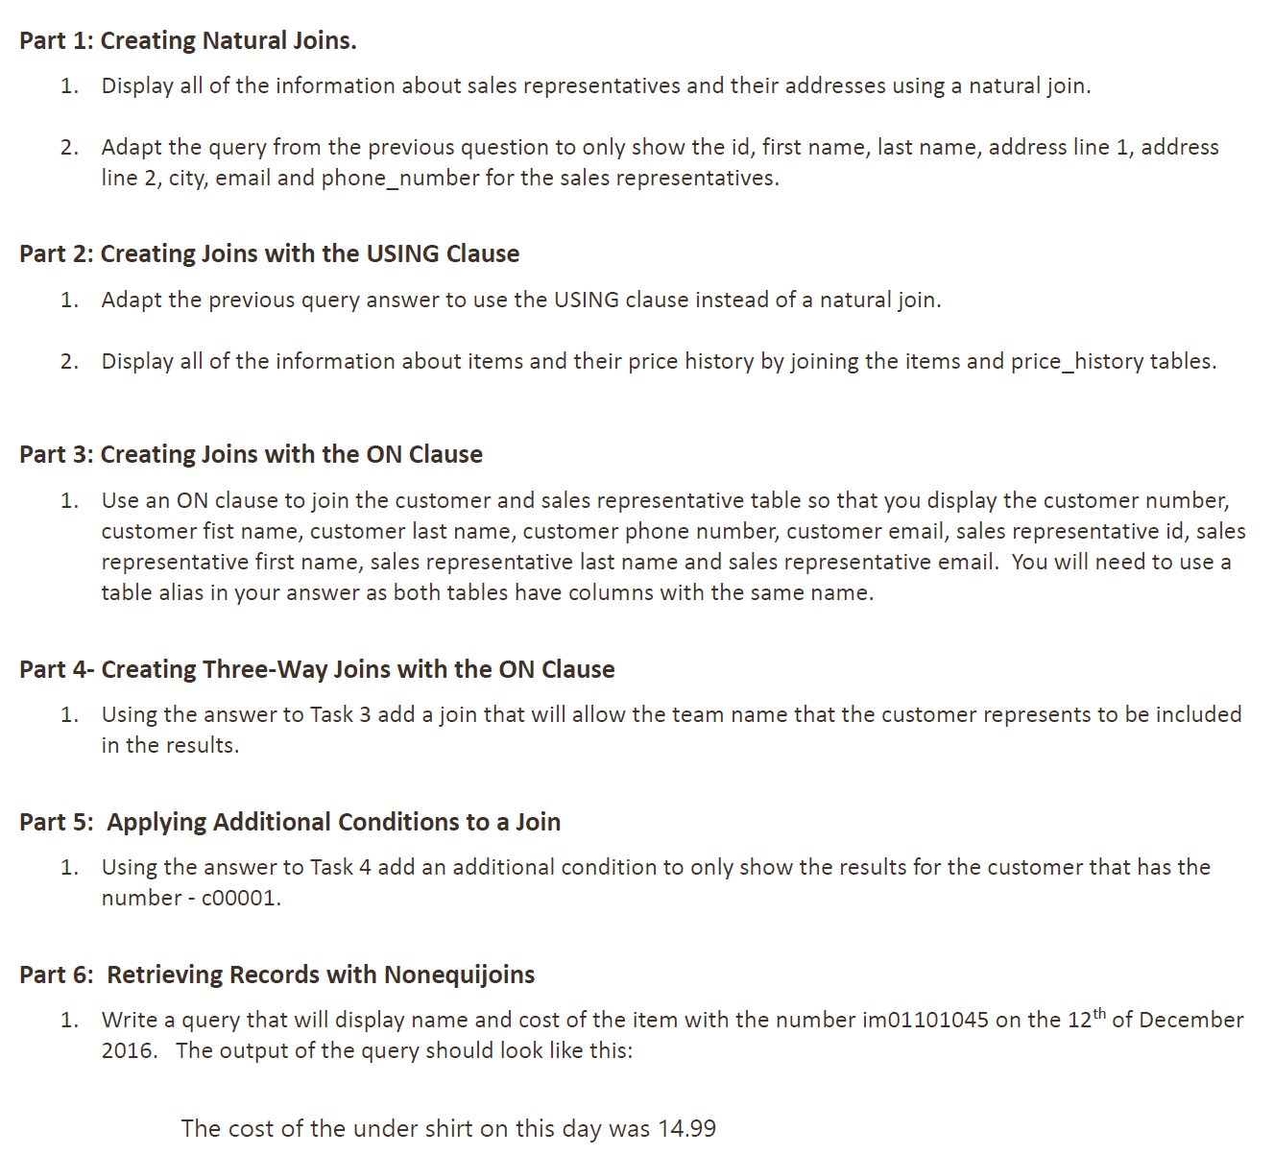

**Answers**:

*Part 1*

1. Natural join

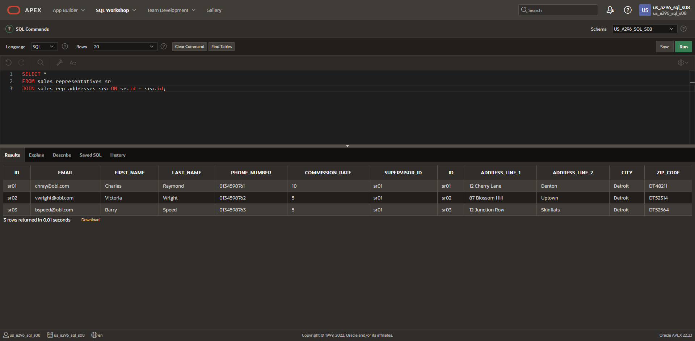

1. Adapted query

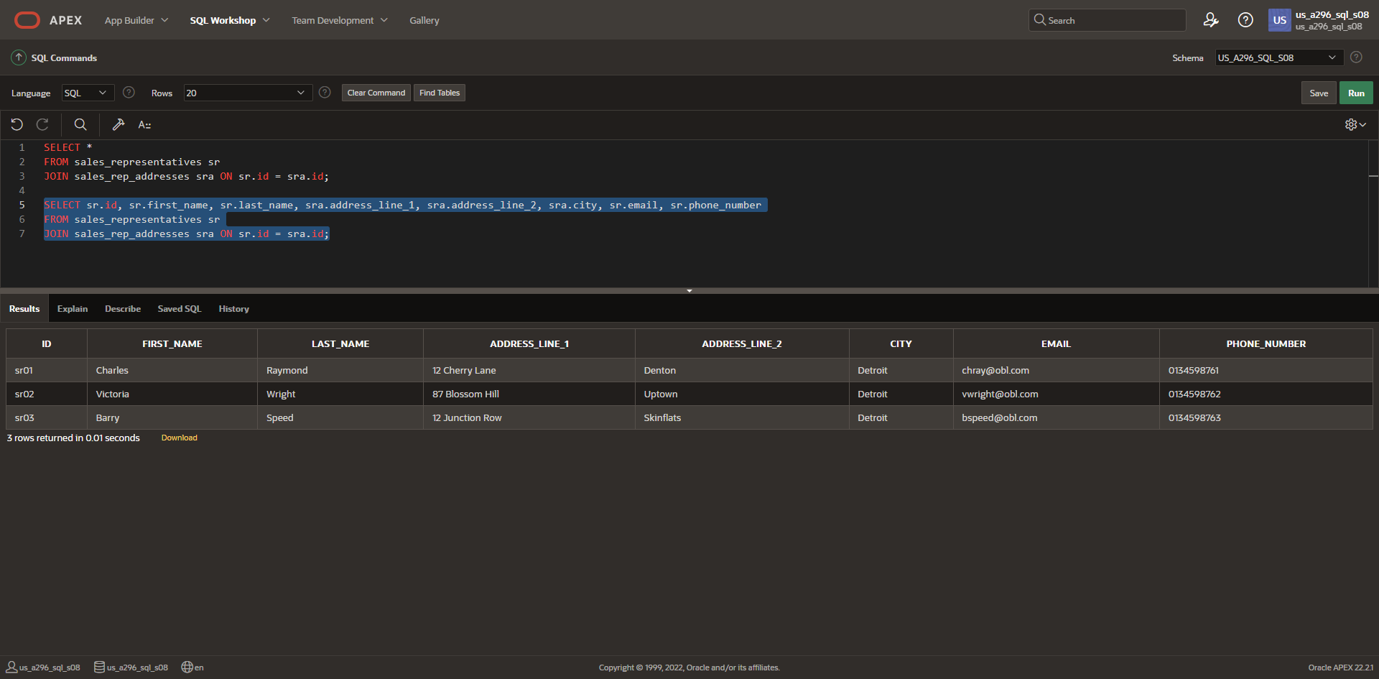

*Part 2*

1. USING clause

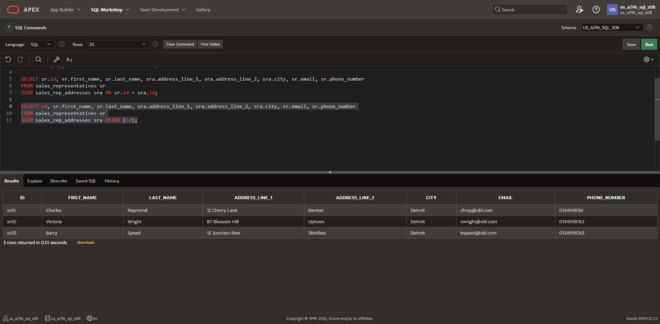

1. Display all information about items and their price history by joining items and price_history

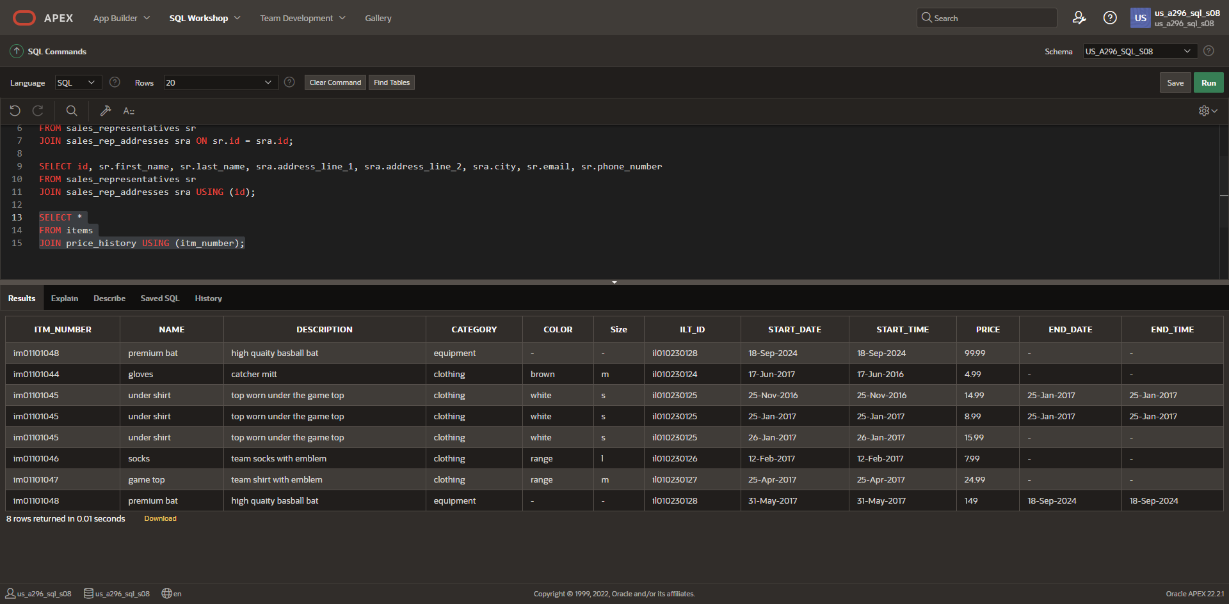

*Part 3*

1. Creating joins with the ON clause

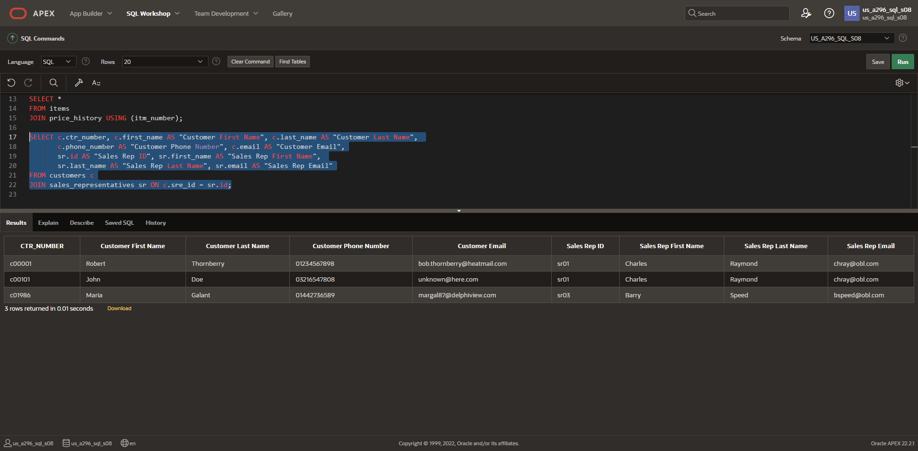

*Part 4*

1. Three-way join

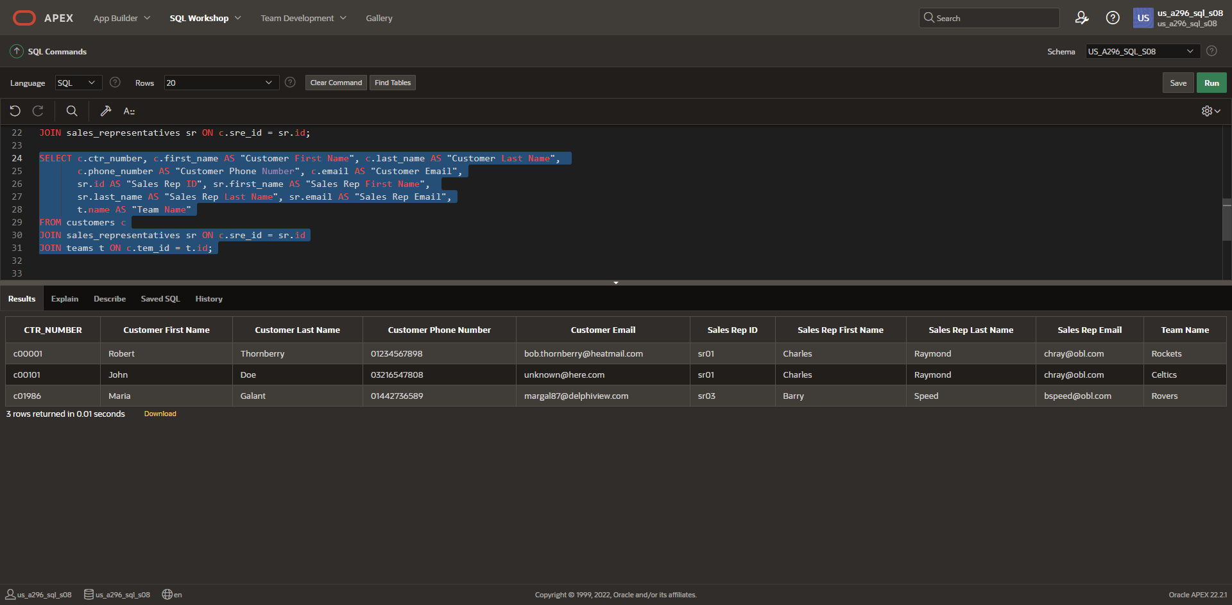

*Part 5*

1. Additional condition

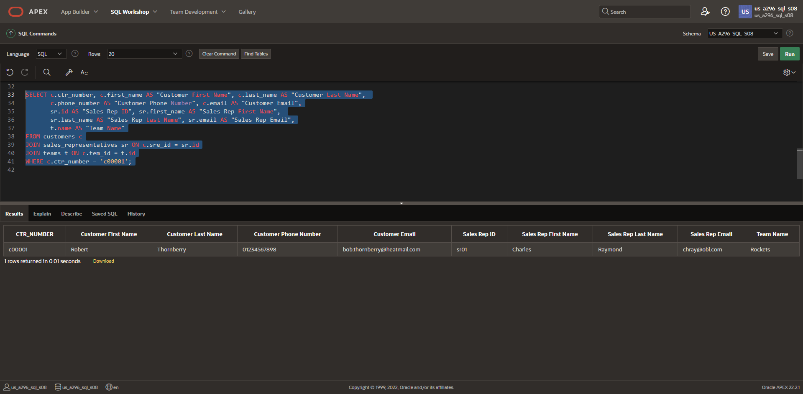

*Part 6*

1. Nonequijoins

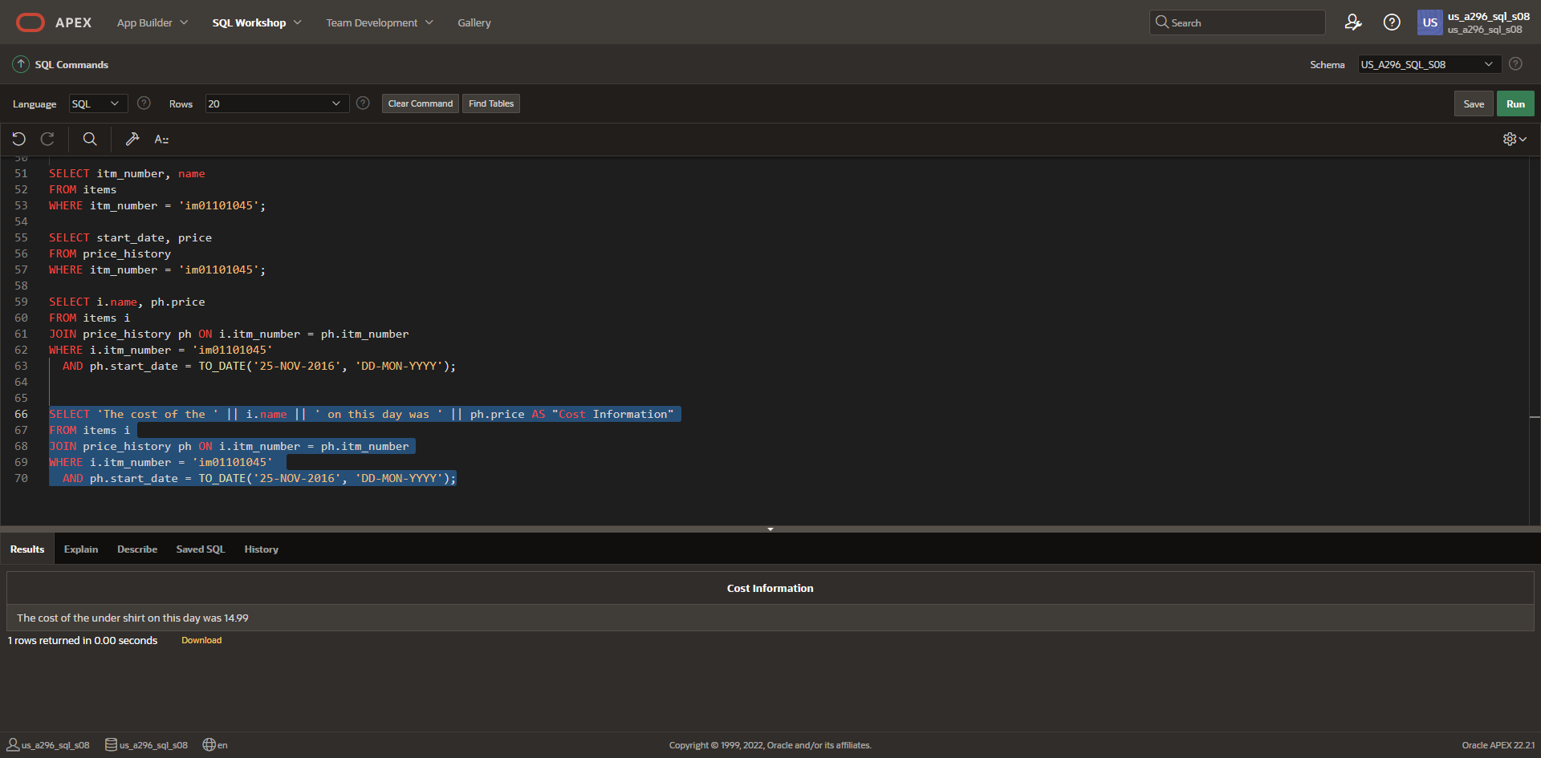

**DFo_6_9_2_Project**

**Questions**:

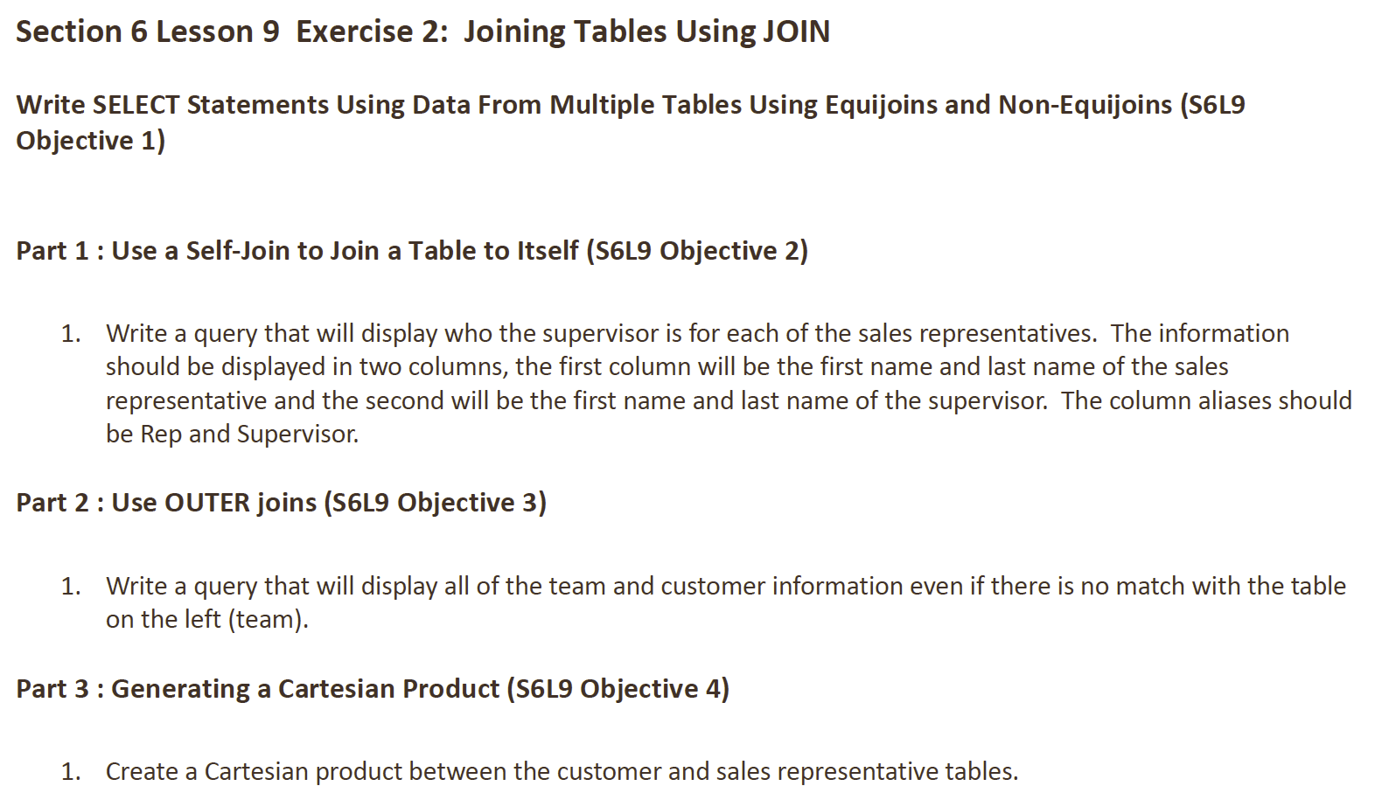

**Answers**:

*Part 1*

1. Self-join

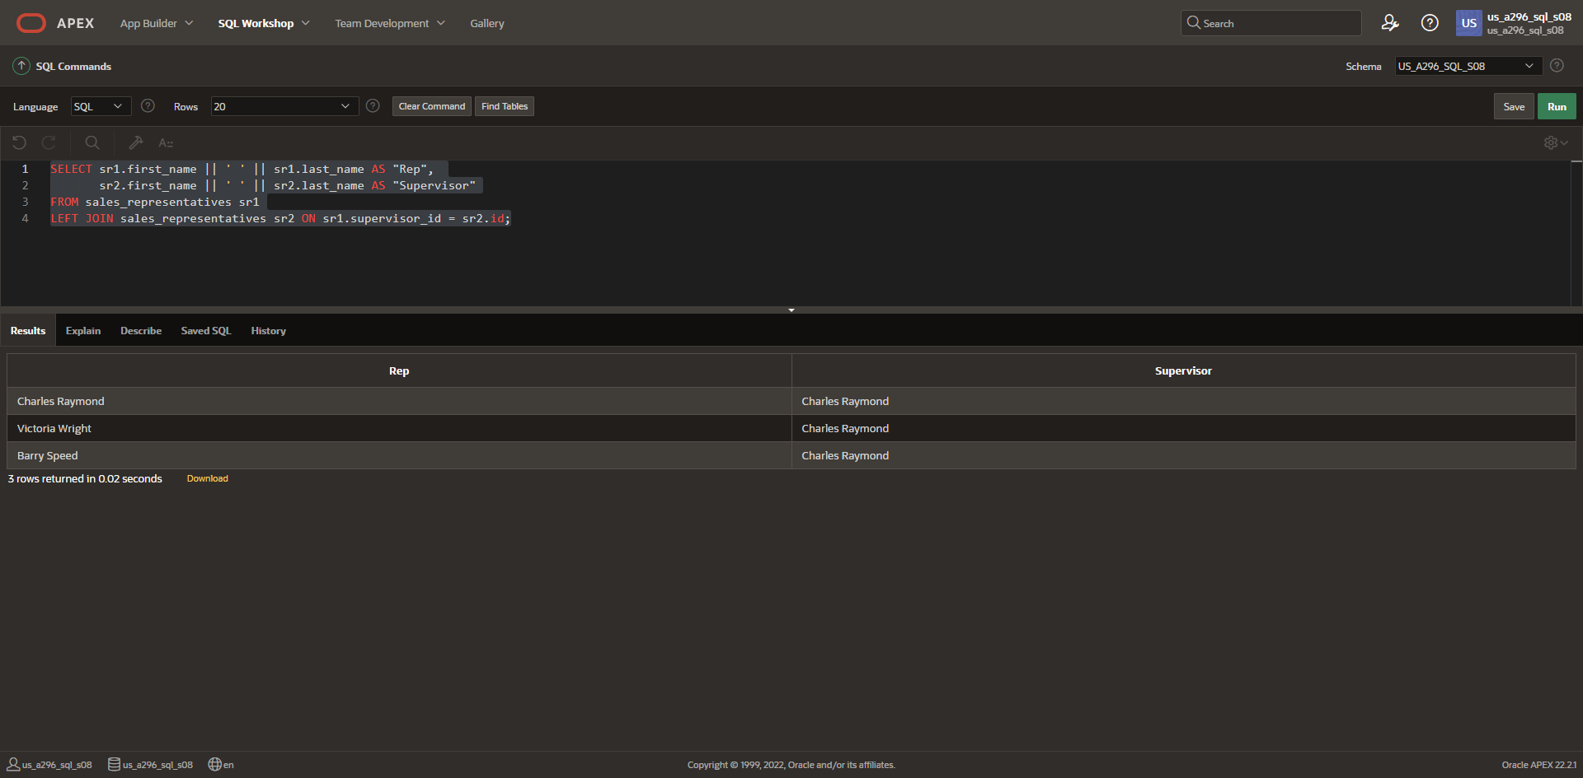

*Part 2*

1. Outer joins

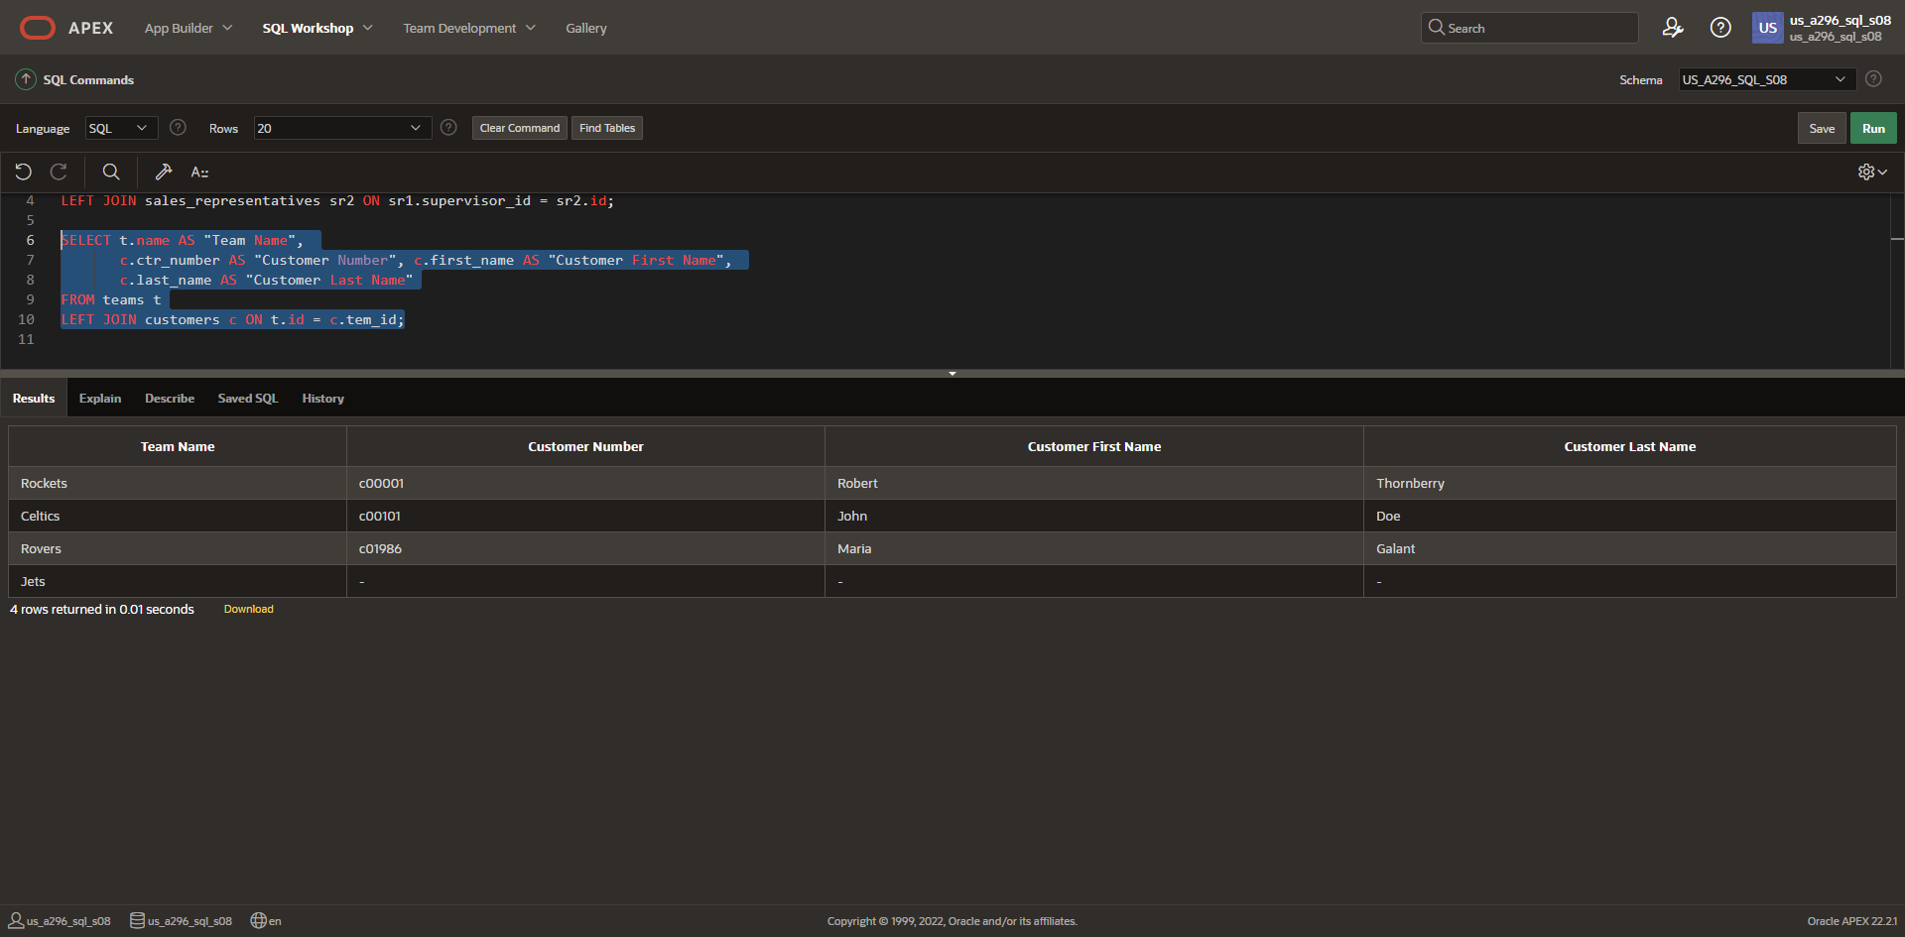

*Part 3*

1. Cartesian product

